C Reg. No. :

Question Paper Code: 52P62

M.E. DEGREE EXAMINATION, NOV 2017
Second Semester
Structural Engineering
15PSE202 - STEEL STRUCTURES
(Regulation 2015)

Duration: Three hours Maximum: 100 Marks
Answer ALL Questions
PART - A (5 x 1= 5 Marks)
1. | Column bases are designed primarily as |  |  |  |  |  | CO1- R
 | (a) Plates |  |  |  | (b) Bearings
 | (c) Studs |  |  |  | (d) Stub columns
2. | _________type of connection used to restrained the end rotation. |  |  |  |  |  | CO2 -U
 | (a) Semi-Rigid |  | (b) Rigid |  |  | (c) Simple | (d) Frame
3. | To resist heavy moment -------- are required. |  |  |  |  |  | CO3- R
 | (a) Channel sections |  | (b) I sections |  |  | (c) Tee sections | (d) Angle sections
4. | Squash load ratio is denoted by |  |  |  |  |  | CO4 -R
 | (a) N/N_{p} |  | (b) N_{p}/N |  |  | (c) Z/Z_{p} | (d) Z/Z_{e}
5. | Compressive stress unit is |  |  |  |  |  | CO5- R
 | (a) kgf/cm² |  |  | (b) kgf/cm³ |  | (c) kg/m² | (d) kgf/mm³
 | PART – B (5 x 3= 15Marks)
6. | List the types of base plates used in practice. CO1-R
7. | Illustrate the types of heavy moment connections? CO2-U
8. | Draw the neat sketch of gantry girder. CO3-U
9. | Distinguish upper bound and lower bound theorem. CO4-U
10. | Define flat width ratio. CO5-U
 | PART – C (5 x 16= 80Marks)
11. | (a) | Design a steel I section purlin from the following data steel with asbestos cement sheet covering  Spacing of truss : 4 m  Spacing of purlins of principle rafters : 1.8 m  Inclination of principle rafter to the main tie : 30 degrees  Wind pressure of roof : 1 kN/m² |  |  |  |  |  | CO1- App | (8)
 |  | Or
 | (b) | A symmetric trusses of span 20m and height 5m are spaced a  4.5m c/c. Design channel section purlin to be placed at suitable distances to resist the following loads,  Weight of sheeting including bolts: 171 kN/m²  Live load: 0.4 kN/m²  Wind load: 1.2 kN/m² (Suction)  Spacing of purlins: 1.4 m |  |  |  |  |  | CO1- App | (16)
12. | (a) | Design a seat angle connection between a beam ISMB 250 and a column ISHB 150 for a factored end reaction of beam 100 kN. Using M20 bolts of 4.6 grade, take Fe410 (f_{y} = 250 N/mm²) grade of steel. |  |  |  |  |  | CO2- App | (16)
 |  | Or
 | (b) | Design welded seat angle connection between a beam ISMB 300 and a column ISHB 200 for a factored end reaction of beam  100 kN, assuming Fe410 grade of steel (f_{y} = 250 Mpa) and site welding. |  |  |  |  |  | CO2- App | (16)
13. | (a) | Briefly explain the types of roof trusses with neat sketch. |  |  |  |  |  | CO3-U | (16)
 |  | Or
 | (b) | Explain the design procedure for gantry girder located at the industrial building. |  |  |  |  |  | CO3-U | (16)
14. | (a) | Determine the elastic section modulus S, plastic section modulus Z, yield moment M_{y}, and the plastic moment M_{p} of the cross-section shown below. What is the design moment for the beam cross-section? Assume Fe500 steel.  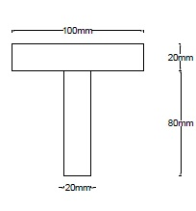 |  |  |  |  |  | CO4 - Ana | (16)
 |  | Or
 | (b) | Determine the plastic moment capacity and shape factor of the  I-section shown in Fig. This section is ISMB400 with the root radius omitted. Assume f_{y} = 250MPa.  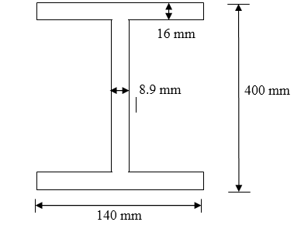 |  |  |  |  |  | CO4 - Ana | (16)
15. | (a) | Calculate the axial capacity of a thin rectangular hollow section of size 150mm x 180mm has a wall thickness of 1.4mm and a radius of 6mm. The effective length of the member is 3.3m. Assume f_{y}=250 MPa. |  |  |  |  |  | CO4 - App | (16)
 |  | Or
 | (b) | A top chord member of a roof truss is of hat section as shown in the fig. It is subjected to a compression of 132.5kN and a moment of 1636 kNm. The span is 1.7m.Check the safety of the section if fy = 210N/mm².  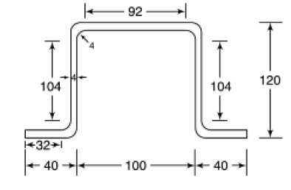 |  |  |  |  |  | CO5-App | (16)

