|  |  |  |  |  |  |  |  |  |  |
| --- | --- | --- | --- | --- | --- | --- | --- | --- | --- |
|  |  |  |  |  |  |  |  |  |  |

**Reg. No. :**

**Question Paper Code: 43075**

B.E. / B.Tech. DEGREE EXAMINATION, NOV 2017

Third Semester

Mechanical Engineering

14UME305 - ENGINEERING MECHANICS

(Regulation 2014)

Duration: Three hours Maximum: 100 Marks

Answer ALL Questions

PART A - (10 x 1 = 10 Marks)

1. If the resultant of two equal forces has the same magnitude as either of the forces, then the angle between the two forces is

(a) 30o (b) 60o (c) 90o (d) 120o

2. Which of following is a scalar quantity

(a) Force (b) Speed (c) Velocity (d) Acceleration

3. How many reaction forces in the fixed support?

(a) 1 (b) 2 (c) 3 (d) 4

4. Three forces acting on a rigid body are represented in magnitude, direction and line of

action by the three sides of a triangle taken in order. The forces are equivalent to a couple

whose moment is equal to

(a) Area of triangle (b) Twice the area of triangle

(c) Half the area of triangle (d) None of these

5. The path of the projectile is

(a) Hyperbola (b) Parabola (c) Involutes (d) Epi-cycloid

6. The center of gravity of a right circular solid cone is at a distance of _______from its

base measured along the vertical axis( h= height of the right solid cone).

(a) h/2(b) h/3 (c) h/4 (d) h/6

7. The bodies which rebound after impact are called

(a) Inelastic bodies (b) Elastic bodies

(c) Neither elastic nor inelastic (d) None of these

8. The law of motion involved in the recoil of gun is

(a) Newton first law of motion (b) Newton second law of motion (c) Newton third law of motion (d) None of these

9. The force required to move the body up the plane will be minimum, if it makes an angle

with the inclined plane __________the angle of friction.

(a) Equal to (b) Less than (c) Greater than (d) None of these

10. The friction experienced by a body ,when in motion is known as

(a) Rolling friction (b) Dynamic friction (c) Limiting friction (d) Static friction

PART - B (5 x 2 =10 Marks)

11. Discuss about Types of Equilibrium.

12. Distinguish between statics and dynamics with examples.

13. Explain polar moment of inertia.

14. State D’Alembert’s principle.

15. Explain limiting friction.

PART - C (5 x 16 = 80 Marks)

16. (a) Four forces act on a bolt A as shown. Determine the resultant of the forces on the bolt.

(K2) (16)

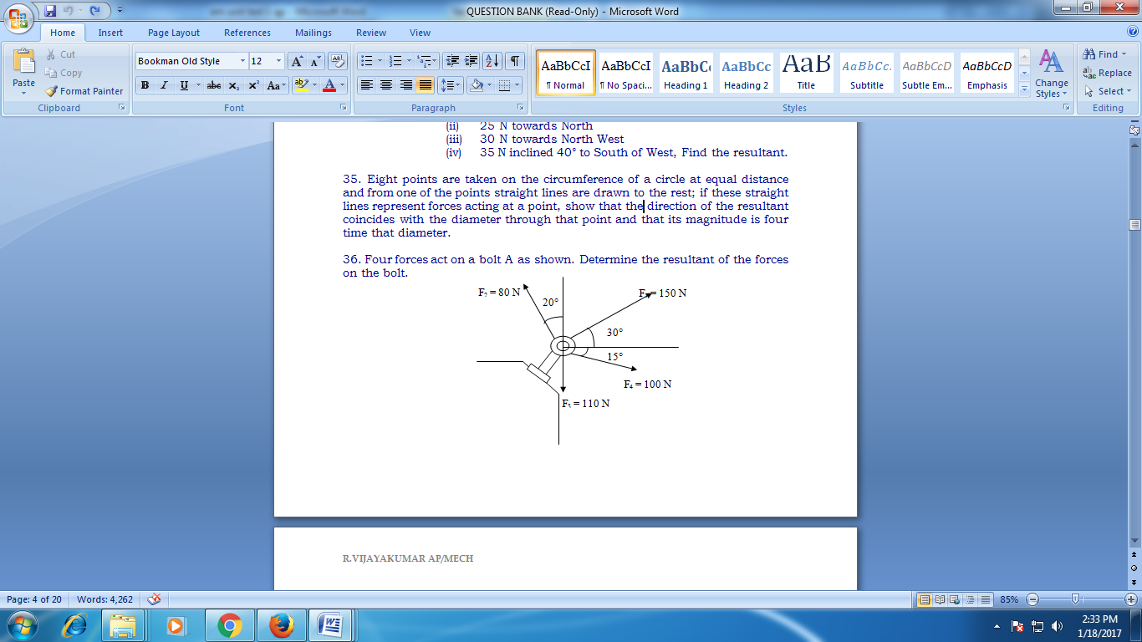

Or

(b) Particle ‘O’ is acted on by the following forces Determine the resultant force.

(i) 20 N inclined 30° North of East

1. 25 N towards North
2. 30 N towards North West
3. 35 N inclined 40° to South of West, Find the resultant. (K2) (16)

17. (a) Three smooth pipes each weighing 20 KN and of diameter 60 cm are to be placed in a

rectangular channel with horizontal base as shown. Calculate the reactions at the points

of contact between the pipes and between the channel and the pipes. Take width of

channel as 160 cm. (16)

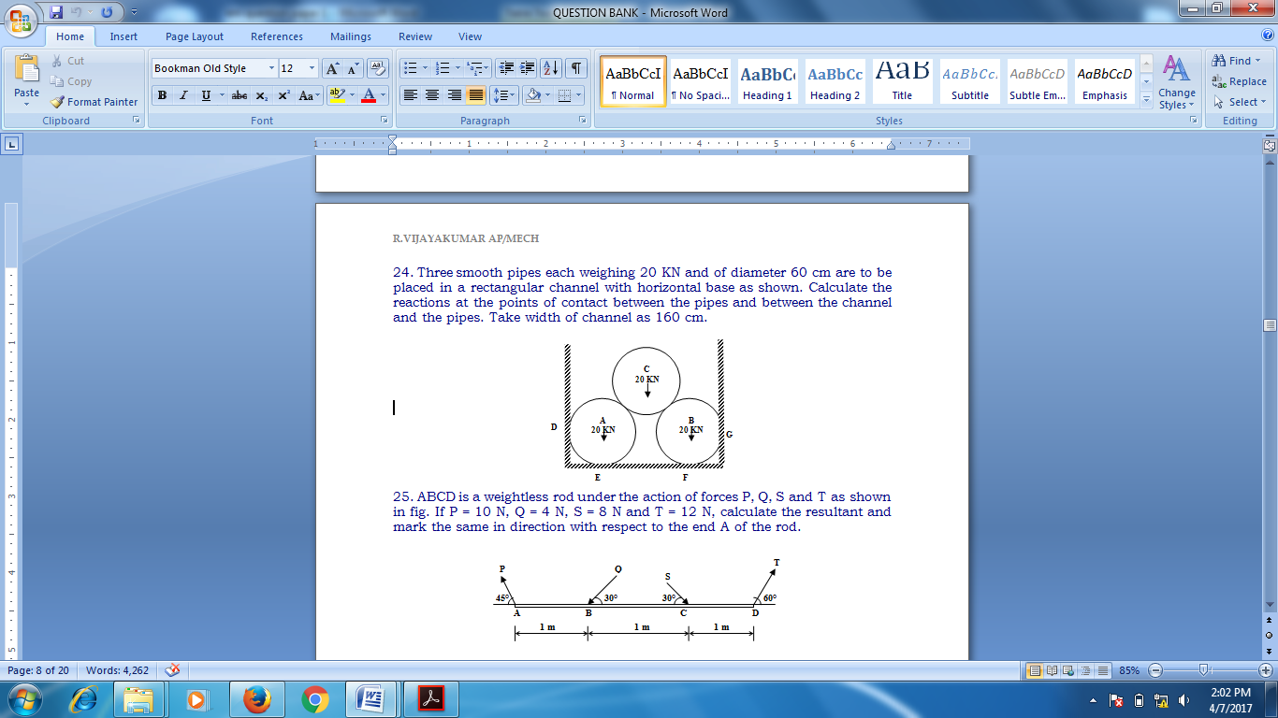

Or

(b) The three forces and a couple of magnitude, M = 18 Nm are applied to an angled

bracket as shown in fig.

(i) Find the resultant of this system of forces

(ii) Locate the points where the line of action of the resultant intersects line AB and line

BC. (16)

18. (a) Locate the centroid of the sectioned area shown in figure. (16)

**100**

**Ø 60 Hole**

**190**

**80**

**140**

**80**

**80**

All dimensions are in mm

Or

(b) Find the moment of inertia of a T section of flange 100 mm x 30 mm and web 20 mm x

80 mm about its centroidal axes. (16)

19. (a) (i) A car starts from rest with a constant acceleration of 4 m/s2. Determine the distance

traveled in the 7th second. (8)

(ii) A body was thrown vertically down from a tower and travels a distance of 3 m in the

5th second of its flight. Find the initial velocity of the body. (8)

Or

(b) A car of mass 300 kg is traveling at 36 km/h on level road. It is brought to rest, after

traveling a distance of 5m. What is the average force of resistance acting on the car?

Find it by applying. (16)

1. Law of conservation of Energy
2. Work-Energy method

(iii) D-Alembert’s principle

20. (a) What should be the value of the angle θ so that motion of the 390 N block impends

down the plane? The co-efficient of friction μ for all surfaces is 1/3. (16)

**130 N**

**390 N**

**θ**

Or

(b) A screw jack has square threads of mean diameter 10 cm and pitch 1.25 cm.

Determine the force that must be applied to the end of 50 cm lever.

(i) To raise and ( ii) To lower a weight of 50 KN. Find the efficiency of the jack.

Assume co efficient of friction is 0.20