|  |  |  |  |  |  |  |  |  |  |
| --- | --- | --- | --- | --- | --- | --- | --- | --- | --- |
|  |  |  |  |  |  |  |  |  |  |

**Reg. No. :**

**Question Paper Code: 44076**

B.E. / B.Tech. DEGREE EXAMINATION, NOV 2017

Fourth Semester

Mechanical Engineering

14UME406 – MACHINE DRAWING

(Regulation 2014)

Duration: Three hours Maximum: 100 Marks

Answer ALL Questions

PART A - (2 x 20 = 40 Marks)

1. (a) Sketch the actual and conventional representation for the following elements:

external thread, splined shaft, helical tension spring, chain wheel and bearing. (20)

Or

(b) (i) Explain the basic size, deviation and tolerance of a geometrical system with a neat sketch. (10)

(ii) Draw the graphical representation of the following geometric characteristics of

the system: (a) form, (b) profile, (c) orientation, (d) location and (e) run out. (10)

2. (a) (i) Sketch and illustrate the terminologies of surface finish / profile. (10)

(ii) With a neat sketch explain the symbols for surface finish obtained by different

machining process. (10)

Or

(b) Explain the various forms of threads and discuss any four forms of threads with neat sketches. (20)

PART - B (1 x 60 = 60 Marks)

3. (a) Assemble the parts of universal coupling as shown in Figure 1 and draw, (i) Half sectional front view and

(ii) Top view (60)

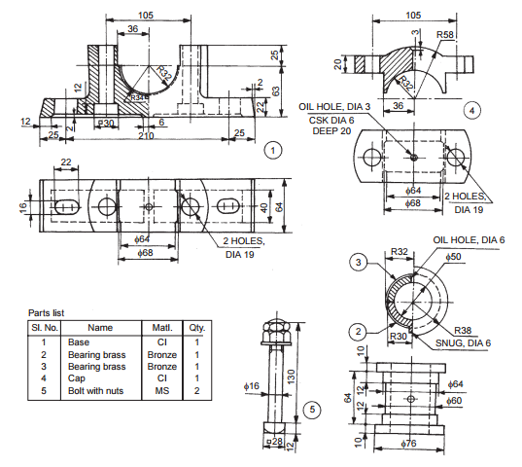

Figure 1

Or

(b) Assemble the parts of a knuckle joint, shown in figure and draw, (i) sectional view from the front and (ii) view from above. (60)

