|  |  |  |  |  |  |  |  |  |  |
| --- | --- | --- | --- | --- | --- | --- | --- | --- | --- |
|  |  |  |  |  |  |  |  |  |  |

**Reg. No. :**

**Question Paper Code: 4907A**

B.E. / B.Tech. DEGREE EXAMINATION, NOV2017

Elective

Mechanical Engineering

14UME910- PROCESS PLANNING AND COST ESTIMATION

(Regulation 2014)

Duration: Threehours Maximum: 100 Marks

Answer ALL Questions.

PART A - (10 x 1 = 10 Marks)

1. In time study, the rating factor is applied to determine

(a) Standard time of a job (b) Merit rating of the worker

(c) Fixation of incentive rate (d)Normal time of a worker

2. Gantt chart is used for

(a) Inventory control (b) Material handling

(c) Production schedule (d) Machine repair schedules

3. Which one of the following chart gives simultaneously information about the progress of

work and machine loading?

(a) Process chart(b) Machine load chart

(c) Man-machine chart (d) Gantt chart

4. A diagram showing the path followed by men and materials while performing a task is

known as

(a) String diagram (b) Flow process chart (c)Travel chart(d) Flow diagram

5. What does the symbol ‘o’ imply in work study

(a) Operation (b) Inspection(c) Delay (d)Transport

6. TMU is a method stands for

(a) Time motion unit (b) Time measurement unit

(c) Time movement unit (d)Time method unit

7. A diagram showing the path followed by men and materials while performing a task is

known as

(a)Travel chart (b)Flow process chart

(c)String diagram (d)Flow diagram

8. The algebraic difference between the minimum limit and the basic size is called

(a)Actual deviation (b) Upper deviation

(c) Lower deviation(d) Fundamental deviation

9. Break even analysis consists of

(a) Fixed expenses(b) Variable cost(c) Sales revenue (d) All of these

10. The work study is done by means of

(a)Planning chart (b)Process chart(c)Stop watch (d)Travel chart

PART - B (5 x 2 = 10 Marks)

11. What are the benefits of Ergonomics?

12. List the process planning activities.

13. Distinguish between cost estimation and cost accounting.

14. Give any two functions of cost estimation

15. Explain overhead expenses.

PART - C (5 x 16 = 80 Marks)

16. (a) (i) Enumerate the basic procedure of work study and describe the methods involved in

the process. (10)

(ii) Discuss about Two-Handed Process Chart, give guidelines for preparing the chart.(8)

Or

(b) (i) Define Ergonomics; Come out with its objectives and applications. (8)

(ii) Design a consideration of Work place layout. (8)

17. (a) Explain the two approaches commonly used in CAPP system bringing out their

advantages and limitations. (16)

Or

(b) What factor should be considered while selecting the best process planning system? (16)

18. (a) (i) Describe the various allowances in estimation. (6)

(ii) List down step by step procedure for estimating the direct material cost. (10)

Or

(b) Examine the purpose of costing? Besides the various methods involved in costing. (16)

19. (a) (i) Explain the terms prime cost, factory cost, total cost and selling price. Show the

relationship between various components of cost with the help of a block diagram.

(8)

(ii) Enumerate the data required and sources of information for cost estimation. (8)

Or

(b) In a manufacturing process, the observed time for 1 cycle of operation is 0.75 min.

The rating factor is 110%. The following are the various allowances as % of normal

time :

Personal allowance = 3%

Relaxation allowance = 10%

Delay allowance = 2% (16)

20. (a) Calculate the total cost of CI (Cast Iron) cap shown in Figure, from the following data:

Cost of molten iron at cupola spout = Rs. 30 per kg, Process scrap = 17 percent of net

wt. of casting , Process scrap return value = Rs. 5 per kg Administrative overhead

charges = Rs. 2 per kg of metal poured, Density of material used = 7.2 gms/cc. The

other expenditure details are :(16)

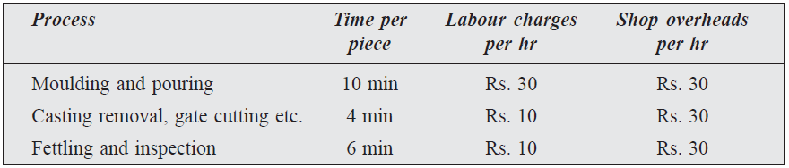

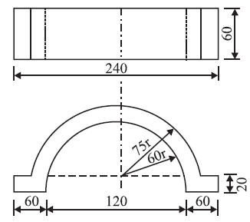

Or

(b) A container open on one side of size 0.5 m × 0.5 m × 1 m is to be fabricated from 6 mm

thick plates Figure. The plate metal weighs 8 gms/cc. If the joints are to be welded,

make calculations for the cost of container. The relevant data is :

Cost of plate = Rs. 10 per kg

Sheet metal scarp (wastage) = 5 percent of material

Cost of labour = 10 percent of sheet metal cost(16)

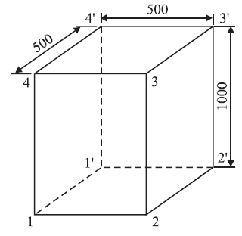

All dimensions in mm