|  |  |  |  |  |  |  |  |  |  |
| --- | --- | --- | --- | --- | --- | --- | --- | --- | --- |
|  |  |  |  |  |  |  |  |  |  |

**Reg. No. :**

**Question Paper Code: 46062**

B.E. / B.Tech. DEGREE EXAMINATION, NOV 2017

Sixth Semester

Instrumentation and Control Engineering

14UIC602-LOGIC AND DISTRIBUTED CONTROL SYSTEMS

(Common to Electronics and Instrumentation Engineering)

(Regulation 2014)

Duration: Three hours Maximum: 100 Marks

Answer ALL Questions

PART A - (10 x 1 = 10 Marks)

1. PLCs having less than \_\_\_\_\_\_ inputs and outputs are called as small PLC

(a) 50 (b) 100 (c) 150 (d) 200

2. In a current sinking DC input module\_\_\_\_\_\_\_\_\_\_\_\_.

(a) The current flows out of the input field device

(b) Requires that a AC sources be used with mechanical switches

(c) The current flows out of the input module

(d) Currents can flow in either direction at the input module

3. The symbol -(L)- represent what instruction in the PLC language?

(a) OUT output unlatch instruction (b) OTL output latch instruction

(c) Examine off instruction (d) Output energize instruction

4. To reset the time for a PLC what condition must be true?

(a) Reset rung of TON must be true

(b) Reset rung of TON must be false

(c) RST instruction with timer address must be true

(d) RST instruction with associated timer address must be false

5. In open loop system

(a) The control action depends on the size of the system

(b) The control action depends on the system variables

(c) The control action depends on the input signal.

(d) The control action is independent of the output

6. BIBO stability is otherwise called as

(a) Zero state stability

(b) Zero input stability

(c) Zero output stability

(d) Zero system stability

7. \_\_\_\_\_\_\_\_\_ configuration provides a dedicated link between two devices.

(a) Multipoint line (b) Point-to-point line (c) Line (d) Single point line

#### 8. A system performs Data acquisition, Networked data communication, \_\_\_\_\_\_\_\_\_ and

#### control.

#### (a) Data representation (b) DCS

#### (c) Microcontroller (d) Data controller

#### 9. Operating system configuration is usually done in \_\_\_\_\_\_\_\_\_\_\_

(a) Online (b) Off-line (c) Inbuilt within the system (d) Either on line or off-line

#### 10. Process field bus (PROFI-BUS) is a

(a) American standard (b) African standard

(c) German standard (d) Asian standard

PART - B (5 x 2 = 10 Marks)

11. Point out the merits and demerits of PLC.

12. Write a simple program using PLC to implement the EXOR logic gate.

13. Draw the general block representation of a computer control system?

14. Compare the configuration of the controller.

15. Give the basic requirments of field bus standards.

PART - C (5 x 16 = 80 Marks)

16.(a) Draw the architecture of PLC and explain individual components. (16)

Or

(b) (i) Sketch and explain the functions performed by analog I/O module. (8)

(ii)With suitable example, Describe the programming counters in Ladder Logic

Diagram. (8)

.

17. (a) Discuss the automatic bottle filling system with hardware and ladder diagram. (16)

Or

(b) Describe the function of program control instructions and develop an example

program to illustrate their use. (16)

18. (a) Determine the closed loop stability of the system shown in Figure 1 when K = 1. (16) . 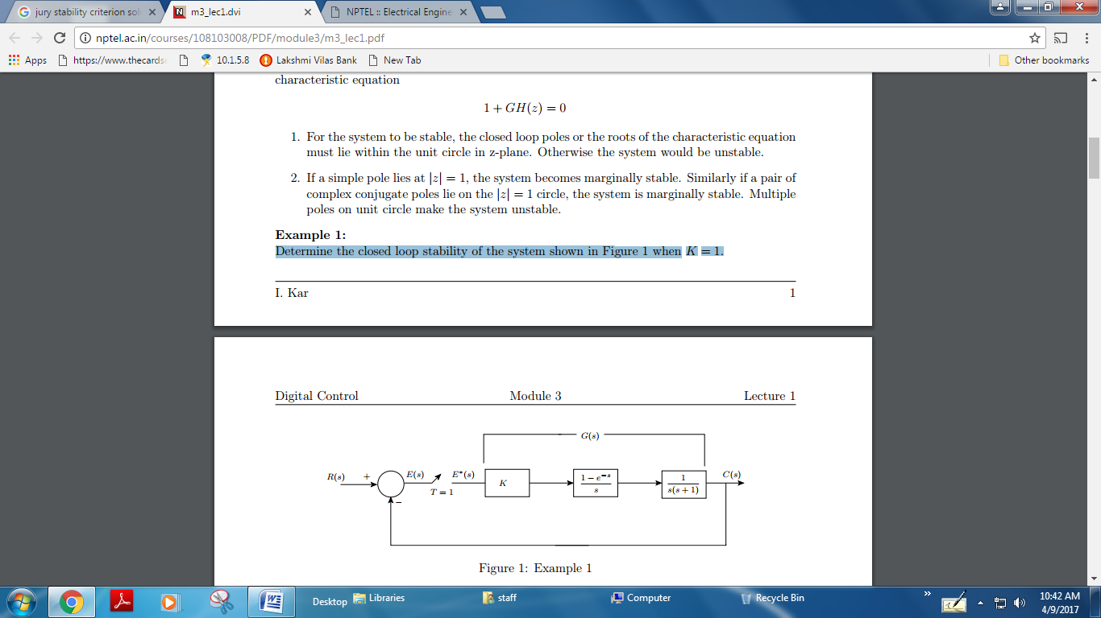

Or

(b) (i) Give the steps to be followed to find the stability of a system using Jury’s

stability test**.**  (8)

(ii) Find the stability of the characteristic equation is (8)

$ P(z)= z^{4}-1.2z^{3}+0.07z^{2}+0.3z-0.08=0$

$ a_{0}=1$$ a_{1}=-1.2$$ a_{2}=0.07$$ a_{3}=0.3$$ a_{4}=-0.08$

19. (a) Illustrate in detail about the architecture and local control unit of DCS. (16)

Or

(b) Discuss the features of low level and high level operator interface of DCS. (16)

20. (a) Illustrate the functioning of HART bus along with its ISO-OSI model

implementation. (16)

Or

(b) With a neat sketch, explain the functioning of FIELD bus with its interoperability

techniques. (16)