|  |  |  |  |  |  |  |  |  |  |
| --- | --- | --- | --- | --- | --- | --- | --- | --- | --- |
|  |  |  |  |  |  |  |  |  |  |

**Reg. No. :**

**Question Paper Code: 52038**

B.E. / B.Tech. DEGREE EXAMINATION, NOV 2017

Second Semester

Civil Engineering

15UEE208 - BASIC ELECTRICAL AND ELECTRONICS ENGINEERING

(Common to Mechanical Engineering, Chemical and Agriculture Engineering)

(Regulation 2015)

Duration: Three hours Maximum: 100 Marks

Answer ALL Questions

PART A - (10 x 1 = 10 Marks)

1. The unit of resistivity is

(a) ohms (b) ohm millimetre (c) ohm metre (d) ohm/metre

2. A 240V, 60W lamp has a working resistance of

(a) 1400 ohm (b) 60 ohm (c) 960 ohm (d) 325 ohm

3. In case of D.C. machines, mechanical losses are primary function of

(a)Current (b) Voltage (c)Speed (d)none of these

4. The armature of DC motor is laminated

(a) To reduce the mass. (b) To reduce the inductor (c) To reduce the eddy current loss. (d) To reduce the hysteresis loss

5. Which of the following diodes is operated in reverse bias mode?

(a)P-N junction (b)Zener (c)Tunnel (d)Schottky

6. A Zener diode is used for

(a) Voltage Regulation (b) Rectification (c) Noise Suppression (d) Blocking A.C

7. The NAND gate output will be low if the two inputs are

(a) 00 (b) 01 (c) 10 (d) 11

8. Which of the examples below expresses the distributive law of Boolean algebra?

(a) A • (B • C) = (A • B) + C (b) A + (B + C) = (A • B) + (A • C) (c) A • (B + C) = (A • B) + (A • C) (d) (A + B) + C = A + (B + C)

9. Radio broadcasting is a familiar example of

(a) space multiplexing (b) time multiplexing (c) frequency multiplexing (d) none of these

10. A cordless telephone using separate frequencies for transmission in base and portable units is known as

(a)duplex arrangement (b)half duplex arrangement (c)either (a) or (b) (d) neither (a) or (b)

PART - B (5 x 2 = 10 Marks)

11. State Ohm’s Law.

12. Why is a single phase induction motor not self-starting?

13. Write the current amplification factor for a CE transistor.

14. State DeMorgan's theorem.

15. Define modulation.

PART - C (5 x 16 = 80 Marks)

16. (a) Determine mesh current of the circuit shown in below figure. (16)

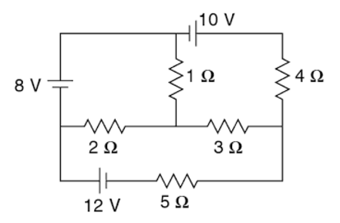

Or

(b) (i) An R-L-C series circuit having a resistance of 60 Ω, inductance of 0.45 H and a

capacitance of 89.6 μF connected across 230V, 50Hz supply. Calculate (a) Impedance (b) Power factor (c) Current (d) Power. (10)

(ii) Derive the expression of RMS and average value for a sinusoidal waveform. (6)

17. (a) Explain the construction and principle of operation of a DC generator with neat sketch. (16)

Or

(b) Explain in detail about construction and working principle of Single Phase Induction Motors and then types? (16)

18. (a) Explain in detail about construction, operation, VI characteristics and applications of PN Junction diode. (16)

Or

(b) What is a Zener diode? Explain the operation of Zener diode and draw its characteristics. (16)

19. (a) Draw and explain the operation of AND, OR, NOT, Ex-NOR and Ex-OR gates with suitable truth table. (16)

Or

(b) Design a half adder and full adder circuits. (16)

20. (a) (i) Draw a neat sketch of a telecommunication system. (8)

(ii) Explain about different methods of modulation. (8)

Or

(b) (i) With help of a neat diagram explain the basic components of satellite communication. (8)

(ii) Explain the block diagram of optical fiber communication systems. (8)