|  |  |  |  |  |  |  |  |  |  |
| --- | --- | --- | --- | --- | --- | --- | --- | --- | --- |
|  |  |  |  |  |  |  |  |  |  |

**Reg. No. :**

**Question Paper Code: 43014**

B.E. / B.Tech. DEGREE EXAMINATION, NOV 2017

Third Semester

Civil Engineering

14UCE304 - MECHANICS OF SOLIDS – I

(Regulation 2014)

Duration: Three hours Maximum: 100 Marks

Answer ALL Questions

PART A - (10 x 1 = 10 Marks)

1. Stress developed in specimen of area of cross section *A* ,due to a suddenly applied load *P* is

(a) *P/A* (b) 2*P/A*  (c) *P/*2*A* (d) None of the above

2. The ratio of lateral strain to longitudinal strain is_________

(a) Young’s modulus (b) Volume modulus (c) Bulk modulus (d) Poisson’s ratio

3. Centroid of a right angled triangle of height *h* and base length *b* is located at a height _________from the base

(a) *h/*3 (b) 2*h* /3 (c) *h*/2 (d) 3*h*/2

4. A fixed beam of length *(l)* carries a point load (*w*) at the centre. The number of points of contra flexure

(a) is one (b) are two (c) are three (d) is none

5. Pure Bending Equation is written as

(a) ==(b) == (c) == (d) none of the above

Where *M* is the moment of Resistance, *I* is the moment of inertia about neutral axis, *f* is the bending stress, *y* is the distance of the extreme fiber from the neutral axis, *E* is the young’s modulus of elasticity and *R* is the radius of curvature of the Neutral Axis.

6. The shear stess required to cause plastic deformation of solid metal is called

(a) proof stress (b) flow stress (c) rupture stress (d) ultimate stress

7. In the torsion equation, the term J/R is called as

(a) shear modulus (b) section modulus (c) polar modulus (d) none of these

8. If a close-coiled helical spring is subjected to load *W* and the deflection produced is *∆*, then the stiffness of the spring is given by

(a) *W/ ∆* (b) *W∆* (c) *∆ / W* (d) *W*2 *∆*

9. In Mohr’s circle of stress, the diameter represents

(a) maximum shear stress (b) deviator stress (c) major principal stress (d) minor principal stress

10. The stress at which the extension of the material takes place more quickly as compared to the increase in load, is called

(a) elastic limit (b) yield point (c) ultimate point (d) breaking point

PART - B (5 x 2 = 10 Marks)

11. Sketch the stress strain curve of the mild steel in tension and mark the salient points.

12. Discuss deficient frame.

13. Enumerate some statically indeterminate beams with examples.

14. What are the stresses developed in the close coiled and open coiled helical spring when it is subjected to an axial load *P*?

15. Define octahedral stresses.

PART - C (5 x 16 = 80 Marks)

16. (a) A bar of length 3 *m* has enlarged square ends of same length is loaded with an axial

force 90 *kN* as shown in the figure. The cross sectional dimensions of the enlarged

portions are given in the diagram. If the middle portion of the bar is also of square

section, find the size and length of the middle portion, if the stress there is 150 *MN/ m*2,

the total elongation of the bar is 0.50 *mm*. Take *E* = 200 *GN/ m*2. (16)

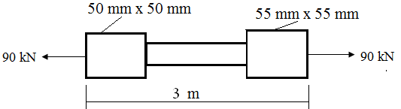

Or

(b) A steel bar of 2*m* long and 40*mm* in diameter is subjected to an axial pull of 80*kN*. Find

the length of 20*mm* diameter bore, which should be centrally carried out, so that the total elongation should increase 20*%* under the same pull. Take *E* = 200*GPa*. (16)

17. (a) Determine the forces in all members of a truss as shown in below figure. (16)



Or

(b) Find the centroid of the composite area shown in figure and also find moment of inertia about its common centroidal *X* axis. (16)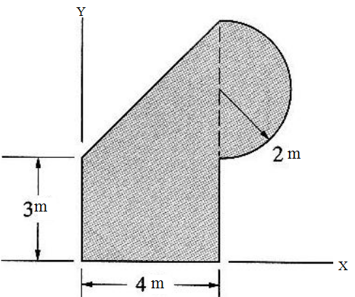

18. (a) Draw shear force and bending moment diagram for an overhanging beam shown in the figure. (16)

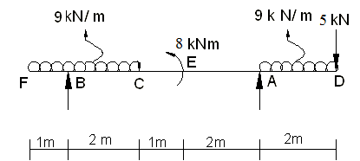

Or

(b) A beam is simply supported and carries UDL of 40*kN/m* run over the whole span. The section of beam is rectangular having depth of 500*mm*. If maximum stress in a material of beam is 120*N/mm2*and moment of inertia of section is 7 x 108*mm*4. Find the span of the beam. (16)

19. (a) Two shafts of same material and same length are subjected to the same torque. If the

first shaft is solid circular section and second shaft is hollow circular section, whose

internal diameter is 2/3 of outside diameter and the maximum shear stress developed

in each shaft is the same. Compare the weight of the shafts. (16)

Or

(b) A close-coiled helical spring made of 12 *mm* diameter steel rod, has 12 complete turns over a mean diameter of 100*mm*. Determine

(i) Increase in the number of runs, and

(ii) Bending stress induced, if it is subjected to an axial twist of 16*N.m*

Take *E* = 2 x105 *N/mm2*. Also compute the torsional stiffness of the spring. (16)

20. (a) An elemental cube is subjected to tensile stress of 30*kN/mm2* and 10*kN/mm2* acting on

two mutually perpendicular planes and a shear stress of 10*kN/mm2* on these planes.

Draw the Mohr’s circle of stresses and determine the magnitudes and direction of

principle stresses and also greatest shear stress. (16)

Or

(b) A rectangular bar of cross sectional area 10000 *mm2* is subjected to an axial load of 20 *kN*. Determine the normal and shear stress on a section which is inclined at an angle of 30° with normal cross-section of the bar. (16)