|  |  |  |  |  |  |  |  |  |  |
| --- | --- | --- | --- | --- | --- | --- | --- | --- | --- |
|  |  |  |  |  |  |  |  |  |  |

**Reg. No. :**

**Question Paper Code: 46014**

B.E. / B.Tech. DEGREE EXAMINATION, NOV 2017

Sixth Semester

Civil Engineering

14UCE604 - STRUCTURAL ANALYSIS – II

(Regulation 2014)

Duration: Three hours Maximum: 100 Marks

Answer ALL Questions

(Smith chart may be permitted)

PART A - (10 x 1 = 10 Marks)

1. When a uniformly distributed load, longer than the span of the girder, moves from left to

right, then the maximum bending moment at mid section of span occurs when the

uniformly distributed load occupies

(a) Less than the left half span (b) Whole of left half span

(c) More than the left half span (d) Whole span

2. What is the variation of influence line for stress function in a statically determinate

structure?

(a) Parabolic (b) Bilinear

(c) Linear (d) Uniformly rectangular

3. Muller Breslau's principle for obtaining influence lines is applicable to i) trusses ii)

statically determinate beams and frames iii) statically indeterminate structures, the

material of which is elastic and follows Hooke's law iv) any statically indeterminate

structure. The correct answer is

(a) (i), (ii) and (iii) (b) (i), (ii) and (iv) (c) (i) and (ii) (d) Only (i)

4.What is the area of influence diagram for the reaction at the hinged end of a uniform

propped cantilever beam of span L?

(a) L/8 (b) L/2 (c) L/4 (d) 3L/8

5. A three hinged symmetrical parabolic arch is hinged at the springing and at the crown.

The span and rise are 40m and 10m respectively. The left half of the arch is loaded with

U.D.L of 3t/m. The horizontal thrust at the springing will be

(a) 15 t (b) 20 t (c) 30 t (d) 40 t

6. For a two-hinged arch, if one of the supports settles down vertically, then the horizontal

thrust

(a) Is increased (b) Is decreased (c) Remains unchanged (d) Becomes zero

7. If in a rigid-jointed space frame, (6m + r) < 6j, then the frame is

.

(a) Unstable (b) Stable

(c) Stable and statically determinate (d) Stable and statically indeterminate

8. A suspension bridge with a two-hinged stiffening girder is statically

(a) Determinate (b) Indeterminate of 1 degree

(c) Indeterminate for 2 degrees (d) Indeterminate for 3 degrees

9. Which section has the largest shape factor ?

(a) Rectangular (b) I section (c) Diamond (d) Solid circular

10. The plastic analysis of structure is applicable to structure made of

(a) Brittle materials (b) Ductile materials

(c) Any type of structural (d) Brittle and ductile

PART - B (5 x 2 = 10 Marks)

11. What is meant by influence line?

12. Define Muller Breslau Principle.

13. State Eddy’s theorem. .

14. Give some examples of beams curved in plan.

15. What are the different types of mechanisms?

PART - C (5 x 16 = 80 Marks)

16. (a) A uniformly distributed load of 1kN per meter run, 6 m long crosses a girder of 16 m

span. Construct the maximum S.F and B.M diagrams and calculated values at

sections 3 m, 5 m, and 8 m from the left hand support. (16)

Or

(b) Four wheel loads of 6, 4, 8 and 5 kN/m cross a girder of 20 m span, from left to right

followed by U.D.L of 4 kN/m and 4 m long with the 6 kN load leading. The spacing

between the loads in the same order 3 m, 2 m and 2 m. The head of the U.D.L is at

2 m form the last 5 kN load. Using influence lines, calculated the S.F and B.M at a

section 8 m from the left support when 4 kN load is at centre of the span. (16)

17.(a) Determine the influence line for RA, RB ,S.F at C and B.M at C for the determinate

beam shown in figure. (16)

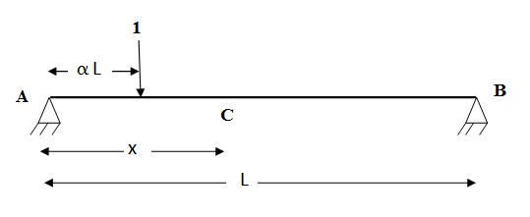

Or

(b) Determine the influence line for RA for the continuous beam shown in figure .

Compute the ordinates at every 1 m interval. (16)

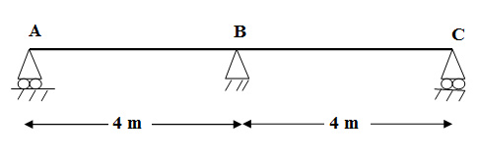

18. (a) A three hinged parabolic arch of 20 m span and 4 m central rise carries a point load

of 4 kN at 4 m horizontally from the left hand hinge. Calculated the normal thrust

and shear force at the section under the load. Also, calculate the maximum bending

mom. (16) Or

(b) A parabolic arch, hinged at the ends has a span 30 m and rise 5 m. A concentrated

load of 12 kN acts at 10 m from the left hinge. The second moment of area varies as

the secant of the slope of the rib axix.Calculated the horizontal thrust and the reactions

at the hinges. Also calculated the maximum bending moment anywhere on the arch. (16)

19. (a) The three hinged stiffening girder of a suspension bridge of 100 m span is subjected

to two point loads of 10 kN each placed at 20 m and 40 m respectively from the left

hand hinge. Determine the B.M and S.F in the girder at section 30 m from each end.

Also, determine the maximum tension in the cable which has a central dip of 10 m.

(16)

Or

(b) A space frame shown in figure is supported at A,B,C and D in a horizontal plane ,

through ball joints. The member EF is horizontal and is at a height of 3 m above the

base. The loads at the joint E and F shown in figure act in a horizontal plane. Find the

forces in all the members of the frame. (16)

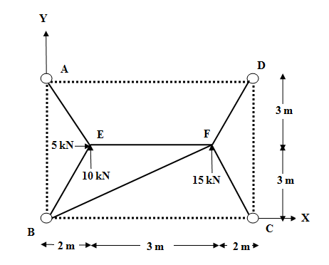

20. (a) Determine the shape factor of unequal I section. The dimensions of the I sections are

given below. (16)

Width of the top flange = 100 mm

Width of bottom flange = 150 mm

Thickness of flange and web = 20 mm

Height of web = 150 mm

Or

(b A portal frame is loaded upto collapse shown in figure. Find the plastic moment of

resistance required if it is of uniform section throughout. Assume Mp is constant for

all the members. (16)

