|  |  |  |  |  |  |  |  |  |  |
| --- | --- | --- | --- | --- | --- | --- | --- | --- | --- |
|  |  |  |  |  |  |  |  |  |  |

**Reg. No. :**

**Question Paper Code: 46011**

B.E. / B.Tech. DEGREE EXAMINATION, NOV 2017

Sixth Semester

Civil Engineering

14UCE601 – DESIGN OF STEEL AND TIMBER STRUCTURES

(Regulation 2014)

Duration: Three hours Maximum: 100 Marks

Answer ALL Questions

PART A - (10 x 1 = 10 Marks)

1. A fillet weld may be termed as

(a) miter weld (b) concave weld

(c) convex weld (d) none of these

2. If *d* is the distance between the flange angles, the vertical stiffeners in plate girders are

spaced not greater than

(a) d (b) 1.25 d (c) 1.5 d (d) 1.75 d

3. ________ used to connect long length of members to reduce the effective length of If the unsupported length of a stanchion is 4 meter and least radius of gyration of its cross- section is 5, the slenderness ratio of the stanchion, is

(a) 60 (b) 70 (c) 80 (d) 90

4. The Indian standard code which deals with steel structures, is

(a) IS : 875 (b)IS : 800 (c) IS : 456 (d) IS : 1893

5. A compression member consisting of angle sections may be a

(a) continuous member (b) discontinuous single angle strut (c) discontinuous double angle strut (d) none of these

6. The strength of a riveted lap joint is equal to its

(a) shearing strength (b) bearing strength (c) tearing strength (d) least of (a), (b) and (c)

7. The minimum pitch of rivet holes of diameter *d* should not be less than

(a) d (b) 1.25 d (c) 1.5 d (d) 1.75 d

8. The strength of a riveted lap joint is equal to its

(a)shearing strength (b) bearing strength (c)tearing strength (d)least of (a), (b) and (c)

9. Group A timber comes under the Modulus of elasticity (E) above

(a) 9.8x103N/mm2 (b) 12.6 x103N/mm2

(c) 5.6 x103N/mm2 (d) all the above

10. The timber to be used in structure must conform to the standards specified in

(a)BIS 3626 – 1969 (b)IS 883 – 1994

(c)IS 3629 – 1986 (d)BIS 3620 - 1980

PART - B (5 x 2 = 10 Marks)

11. Define efficiency of a joint.

12. Define net sectional area..

13. List out the failures modes of column sections.

14. What do you mean by web buckling?

15. What are all the permissible defects in structural timber?

PART - C (5 x 16 = 80 Marks)

16. (a) Find the efficiency of the lap joint shown in fig. below, Given: M20 bolts of grade

4.6 and Fe 410(E 20) plates are used. (16)

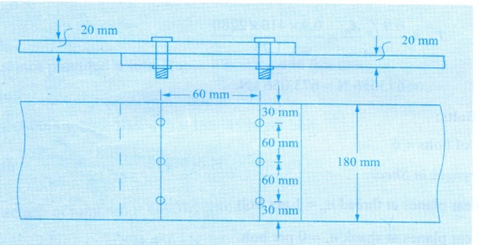

Or

(b) Design a lap joint between the two plates each of width 120*mm*, if the thickness of one plate is 16*mm* and the other is 12*mm*. The joint has to transfer a design load of 160*kN*. The plates are of Fe410 grade. Use bearing type bolts. (16)

17. (a) Determine the design tensile strength of the plate 200 *mm* x 12 *mm* with the holes for 16 *mm* diameter bolts as shown in figure. Steel used is of Fe415 grade quality. (16) 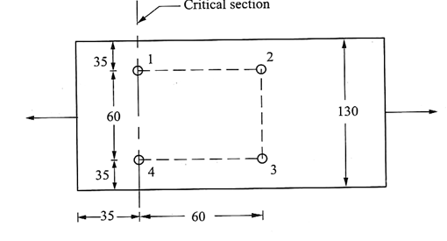

Or

(b) A tension member consists of two angle section and carries a load of 200kN. Design

the member when both the angles are connected (a). On both sides of gusset plate (b)

On the same side of gusset plate. (16)

18. (a) Design a laced column with two channels back to back of length 10*m* to carry an axial factored load of 1400*kN*. The column may be assumed to have restrained in position but not in direction at both ends. (16)

Or

(b) A column section ISHB 350@661.2N/m carries an axial load of 1100kN. Design a

suitable gusset basing by using riveted connection. (16)

19. (a) Design a simply supported beam of effective span 1.5 *m* carrying a factored concentrated load of 360 *kN* at mid span. (16)

.

Or

(b) Design the maximum section of a plate girder for a bridge live load of 60kN/m,

longer than the span and the dead load of 40kN/m. the girder is simply supported

over an effective span of 12m. Take impact factor 20/ (14+L). (16)

20. (a) Design a timber column for inside location for following data:-

Type of wood =Kail, Unsupported length = 3015m, Axial load = 350kN.. (16)

Or

(b) A compression member is made of 150*mm* x 60*mm* deodar wood and it is 2*m*  long.

The member is subjected to a compressive load of 16.5*kN* and a bending moment

of 800*Nm*. Investigate the safety of the design. Safe compressive stress due to axial

load: as per code. Safe bearing stress: 10*N/mm*2. (16)