|  |  |  |  |  |  |  |  |  |  |
| --- | --- | --- | --- | --- | --- | --- | --- | --- | --- |
|  |  |  |  |  |  |  |  |  |  |

**Reg. No. :**

**Question Paper Code: 52016**

B.E. / B.Tech. DEGREE EXAMINATION, NOV 2017

Second Semester

Civil Engineering

15UCE206 - BASIC ENGINEERING MECHANICS

(Regulation 2015)

Duration: Three hours Maximum: 100 Marks

Answer ALL Questions

PART A - (10 x 1 = 10 Marks)

1. If two forces of 3kg and 4kg act at right angles to each other, their resultant force will be equal to

(a) 7kg (b) 1kg (c) 5kg (d) 1/7kg

2. Effect of a force on a body depends upon its

(a) Direction (b) Magnitude (c) Position (d) All the above

3. Characteristics of a couple

(a) Algebraic sum of the forces is zero (b) Algebraic sum of the moment is zero (c) It is the product of force and distance (d) None of these

4. Reactions at the supports of a structure can be determined by equating the algebraic sum of

(a) Horizontal forces to zero (b) vertical forces to zero (c) moments about any point to zero (d) all the above

5. The coefficient of friction between two surfaces is 0.2. Then the angle of friction as

(a) *sin-1*(0.2) (b) *cos-1*(0.2) (c) *tan-1*(0.2) (d) *cot-1*(0.2)

6. The maximum frictional force which comes into play, when a body just begins to slide over the surface of a other body, is known

(a) sliding friction (b) rolling friction (c) limiting friction (d) none of these

7. The position of CG of a solid hemisphere of radius *r* lies on the central radius at a distance from the plane base

(a) (b) (c) (d)

8. The Centre of gravity of a 10 cm x 15 cm x 5 cm T section from its bottom, is

(a) 7.5 cm (b) 5.0 cm (c) 8.75 cm (d) 7.85 cm

9. The units of the moment of inertia of an area are

(a) Kg m2 (b) Kg / m2 (c) Kg m4 (d) Kg / m4

10. The ratio of the moment of inertia of a rectangle about its centroidal axis to the moment of inertia about its base, is

(a) 1/4 (b) 1/2 (c) 3/4 (d) 2

PART - B (5 x 2 = 10 Marks)

11. Define resultant force.

12. Define tension co-efficient.

13. How can you classify the dynamic friction?.

14. Difference between centroid and centre of gravity.

15. Illustrate parallel axis theorem.

PART - C (5 x 16 = 80 Marks)

16. (a) A string ABCD, attached to two fixed points A and D has two equal weights of 1000N attached to it at B and C. The weights rest with the portions AB and CD inclined at angles of 30ᵒ and 60ᵒ respectively, to the vertical as shown in fig. 2. Find the tensions in the portions AB, BC and CD of the string, if the inclination of the portion BC with the vertical is 120ᵒ. (16)

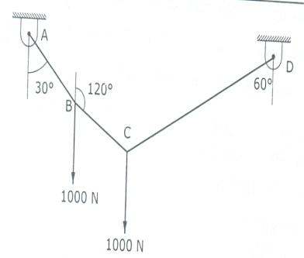

Or

(b) A car is pulled by means of two cars as shown in fig. If the Resultant of the two forces acting on the car A is 40 kN being directed along the positive direction of X axis, determine the angle θ of the cable attached to the car at B, such that the force in cable AB is minimum. What is the magnitude of force in each cable when this occurs. (16)

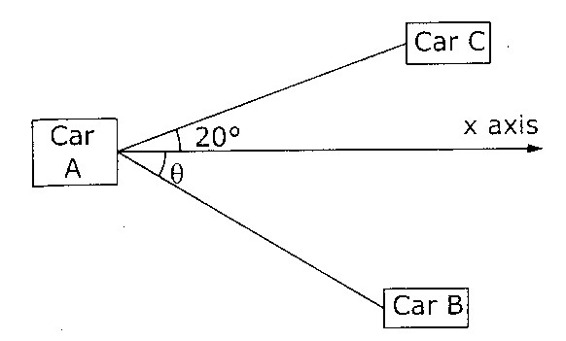

17. (a) Determine the member forces of the cantilever truss shown in fig, using method of

joints. (16)

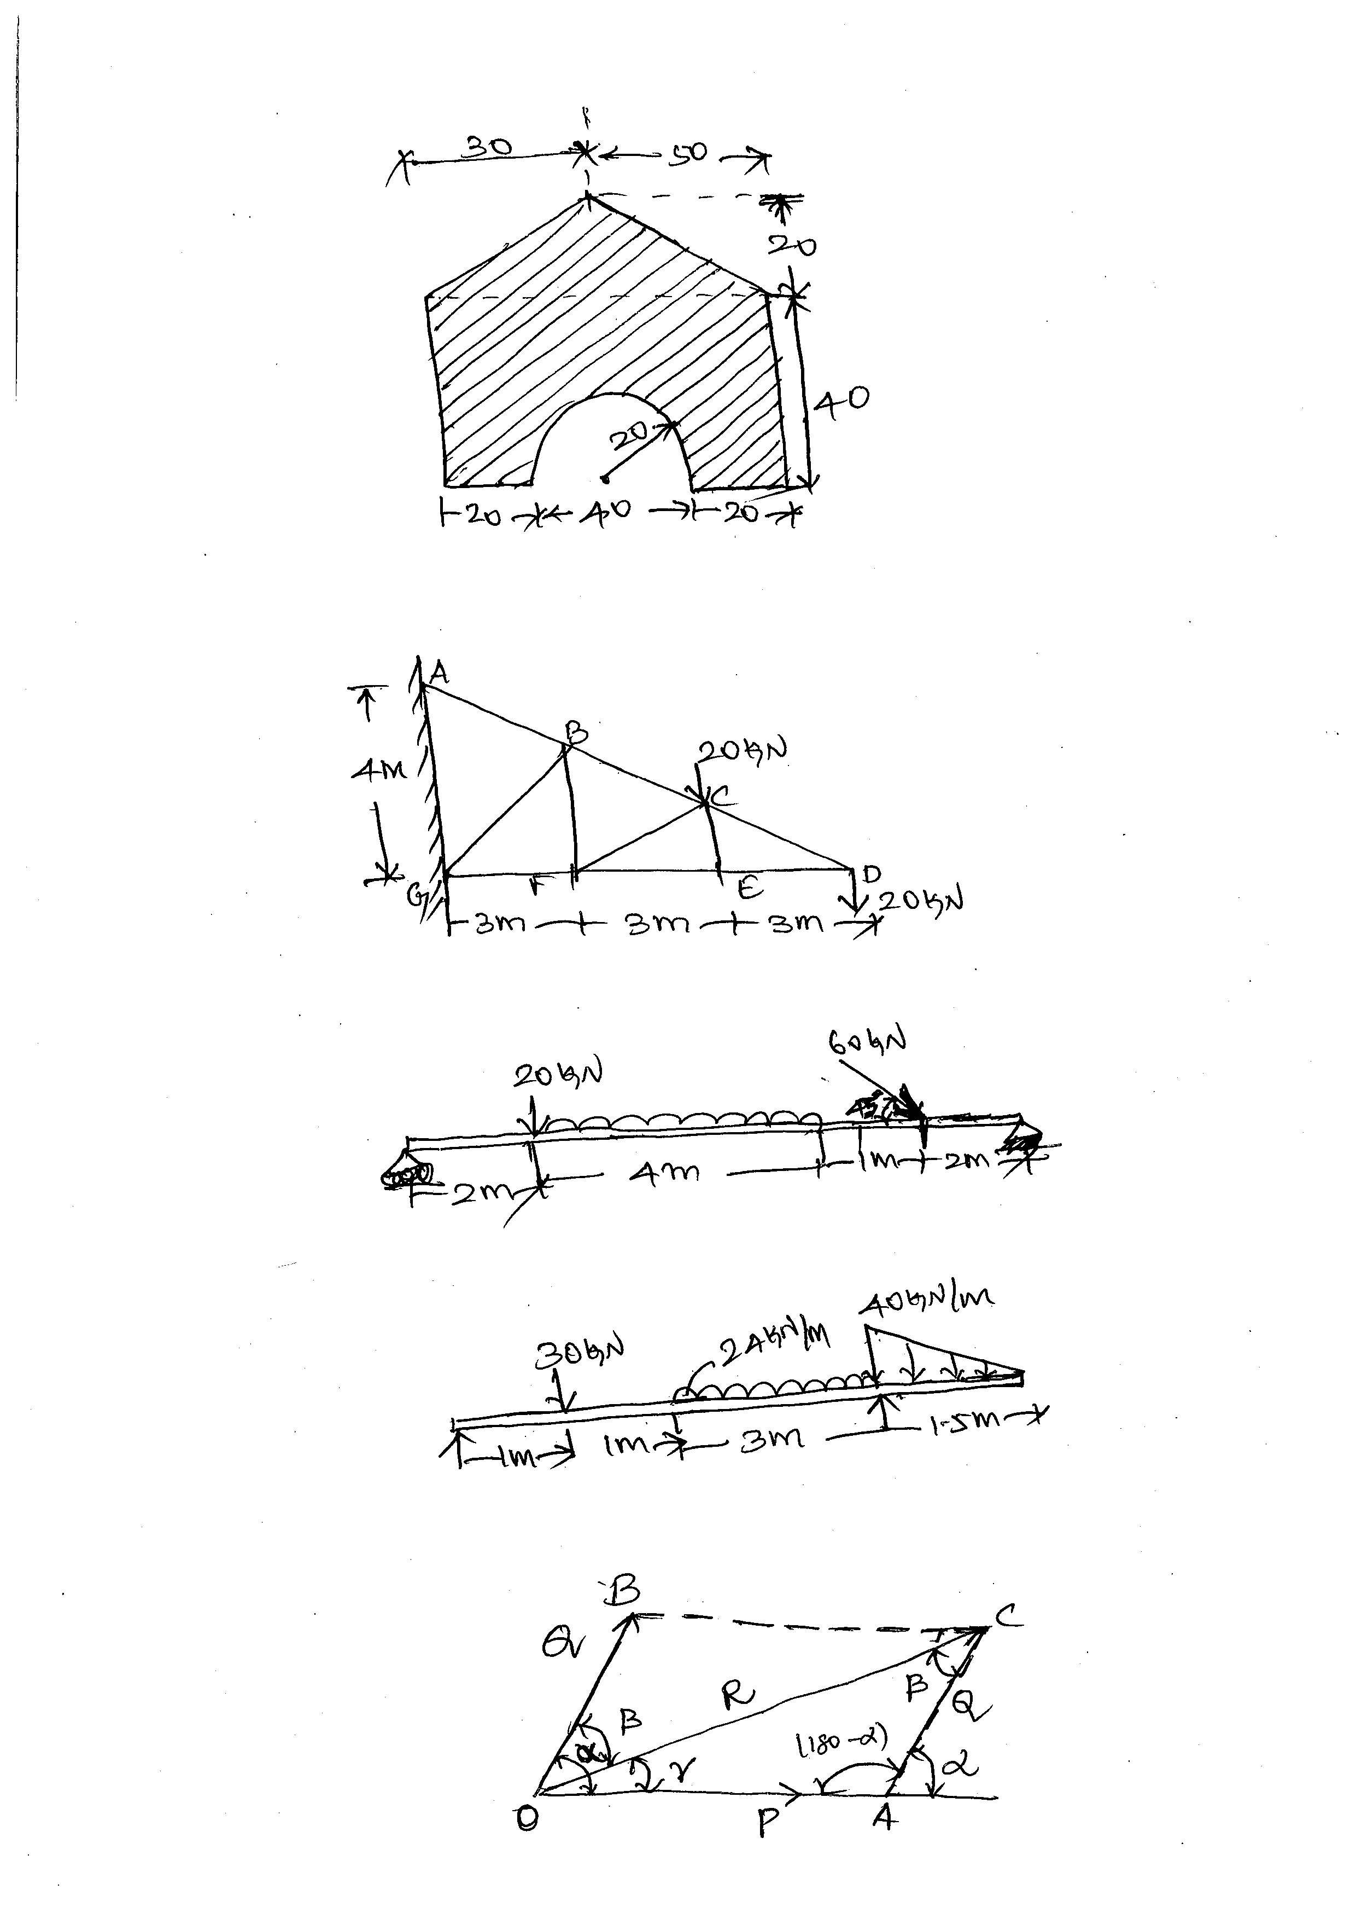

Or

(b) Determine the forces in all the members of the truss shown in figure by method of joints. (16)

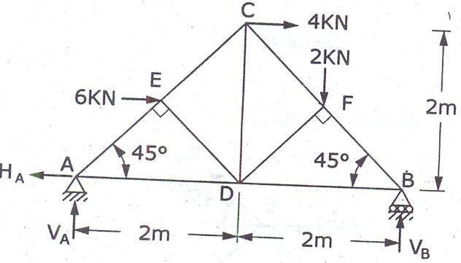

18. (a) A uniform ladder of weight 1000 N and of length 4 m rests on a horizontal ground and leans against a smooth vertical wall. The ladder makes an angle of 60° with horizontal. When a man of weight 750 N stands on the ladder at a distance 3 m from the top of the ladder, the ladder is at the point of sliding. Determine the co-efficient of friction between the ladder and the floor. (16)

Or

(b) An open – belt drive connects two pulleys 120 cm and 50 cm diameters, on parallel shafts 4 m apart. The maximum tension in the belt is 1853.3 N. The coefficient of friction is 0.3. The driver pulley of diameter 120 cm runs at 200 r.p.m. Calculate: (i) the power transmitted, and (ii) torque on each of the two shafts. (16)

19. (a) For the plane area shown in figure , determine the location of centroid. (16)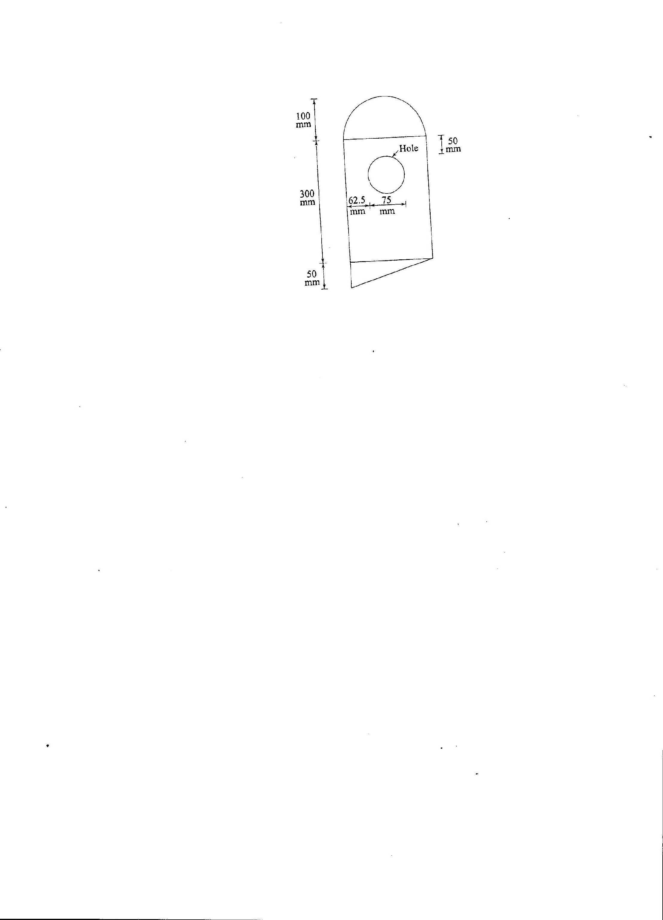

Or

(b) Loacate the centroid of the section shown in fig. all dimensions are in *mm*. (16)

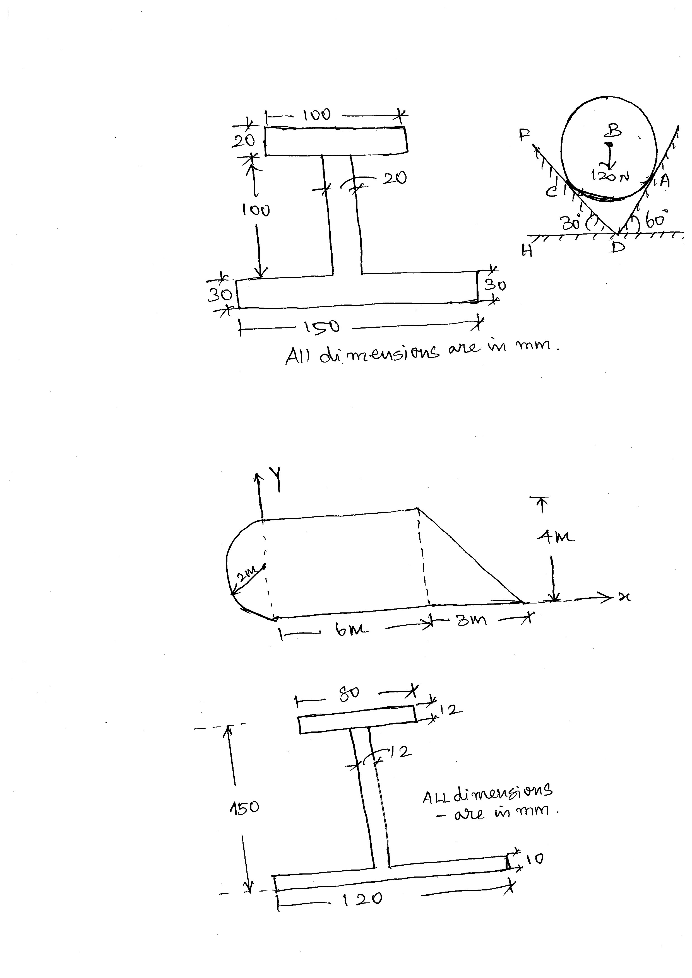

20. (a) Determine the moment of inertia about the centroidal axes of the I-section shown in Figure . (16)

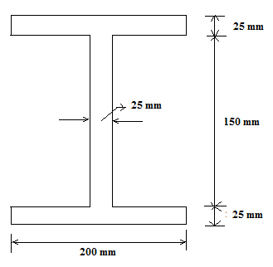

Or

(b) Locate the principal axes and determine the principal moments of inertia of an angle section, shown in figure. (16)

