|  |  |  |  |  |  |  |  |  |  |
| --- | --- | --- | --- | --- | --- | --- | --- | --- | --- |
|  |  |  |  |  |  |  |  |  |  |

**Reg. No. :**

**Question Paper Code: 52118**

B.E. / B.Tech. DEGREE EXAMINATION, NOV 2017

Second Semester

Biomedical Engineering

15UBM208 - ELECTRICAL CIRCUITS ANALYSIS

(Regulation 2015)

Duration: Three hours Maximum: 100 Marks

Answer ALL Questions

PART A - (10 x 1 = 10 Marks)

1. The 100Ω resistors of 1KΩ each are connected in parallel. Their equivalent resistance will be

(a) 0.01Ω (b) 0.1Ω (c) 1Ω (d) 10Ω

2. KCL states that at any node in a circuit the algebraic sum of currents entering and leaving a node at any instant of time must be equal to

(a) One (b) Zero (c) Two (d) Three

3. A source has an emf 10 V and impedance 500+j100 ohms. The amount of maximum power transferred will be

(a) 0.5mW (b) 0.05mW (c) 0.05W (d) 0.5W

4. Norton’s theorem is also called

(a) Reciprocity theorem (b) Superposition theorem (c) Thevenin’s theorem (d) Dual of the thevenin’s theorem

5. An RLC circuit has R=200Ω,C=5µ F and L=0.1H.The natural frequency of the circuit is

(a) 10 radians/second (b) 100 radians/second (c) 1000 radians/second (d) 10000 radians/second

6. At resonance inductive reactance is equal to the

(a) Capacitive reactance (b) Q-factor (c) Impedance (d) Admittance

7. A series RL circuit has R=50ohms and L=10H.The voltage applied is 100 volts at t=0 by the closing of a switch. The equation for current is

(a) 2(1-e-5t) (b) 2(1+e-5t) (c) 2(1-e+5t) (d) 2(1+e5t)

8. ________ is the ratio of actual resistance in the circuit to the critical resistance.

(a) Natural frequency (b) Damping ratio (c) Critical resistance (d) Over damped

9. Three phase system give ________ output.

(a) DC (b) Constant (c) Steady (d) Poor

10. Write the relation between phase voltage and line voltage in three phase balanced star system

(a) Eɸ = EL**/** (b) Eɸ = EL (c) Eɸ = EL**/**3 (d) EL= Eɸ **/**

PART - B (5 x 2 = 10 Marks)

11. Name different network elements.

12. State superposition theorem.

13. How is selectivity related to bandwidth?

14. What is the time constant for series RC circuits.

15. Differentiate between balanced and unbalanced star connected load.

PART - C (5 x 16 = 80 Marks)

16. (a) Write the mesh equations for the circuit shown in the figure and solve for current in the 12 Ω resistor. (16)

D:\1. Engg cbt\Bookwork 2011-2012\Electric Circuit Theory\01 DC fundamentals\WMF IMAGE\fig26.wmf

Or

(b) Find the current through each resistor of the circuit shown in the fig, using nodal analysis. (16)

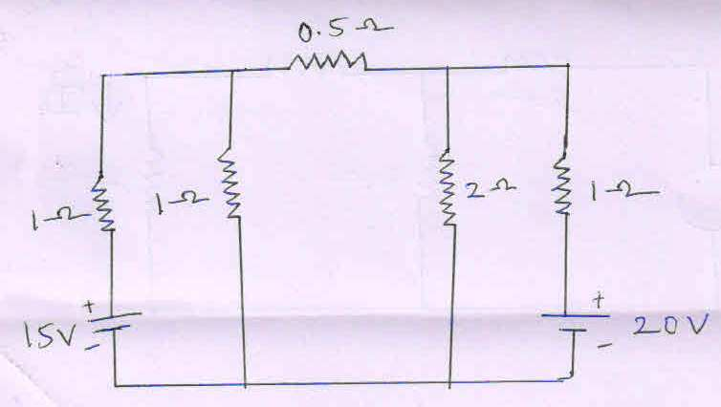

17. (a) A linear time invariant network when terminated with i) R = 1Ω, the current is 5< -450 A ii) XC = 1Ω, the current is 10 <-450 A. Find the thevenin’s equivalent of the network. What will be the current if it is terminated with XL = 1Ω. (16)

Or

(b) (i) Reduce the following circuit convert into a single equivalent source. (8)

D:\1. Engg cbt\Bookwork 2011-2012\Electric Circuit Theory\01 DC fundamentals\WMF IMAGE\fig17.wmf

(ii) For the network shown in the figure below, find the equivalent resistance between the terminals B and C. (8)

D:\1. Engg cbt\Bookwork 2011-2012\Electric Circuit Theory\01 DC fundamentals\WMF IMAGE\star-Detla\Fig-6.wmf

18. (a) In series RLC circuit with variable capacitance, the current is at maximum value with capacitance of 20 µF and the current reduces to 0.707 times maximum value with capacitance of 30 µF. Find the values of R and L. What is the bandwidth of circuit if supply voltage is 20 sin (6.28 x 103 ) t volts. (16)

Or

(b) **(i)** Derive the expressions for equivalent inductance of two coils in series with (i) Parallel aiding (ii) Parallel opposition. (12)

(ii) Define self and mutual inductance. (4)

19. (a) Derive expression for RL transient in an electric circuit for DC excitation. (16)

Or

(b) Write a note on underdamped, overdamped and critically damped systems. (16)

20. (a) Explain power measurement by two-wattmeter method for balanced load and unbalanced load. (16)

Or

(b) Draw a waveforms of 3-phase voltages and Illustrate the generation of three phase voltage system. (16)