|  |  |  |  |  |  |  |  |  |  |
| --- | --- | --- | --- | --- | --- | --- | --- | --- | --- |
|  |  |  |  |  |  |  |  |  |  |

**Reg. No. :**

**Question Paper Code: 49076**

B.E. / B.Tech. DEGREE EXAMINATION, NOV 2017

Elective

Mechanical Engineering

14UME910- PROCESS PLANNING AND COST ESTIMATION

(Regulation 2014)

Duration: Three hours Maximum: 100 Marks

Answer ALL Questions.

PART A - (10 x 1 = 10 Marks)

1. Which process chart symbol is used to Process Chart Symbols for permanent storage

(a) Equilateral triangle (b) Circle (c) Square (d) Rectangle

2. Which techniques are commonly used in work measurement

(a) Time study (b) Work sampling

(c) Pre-determined Motion Time System (PMTS) (d) All of the above

3. In Batch Production, the products are made in

(a) Small batches and in Less variety (b) Small batches and in Large variety

(c) Large batches and in Large variety (d) None of the above

4. Production of books in printing presses is_________________type of process.

(a) Job Shop Production (b) Batch Production

(c) Mass production (d) Continues flow

5. Factory cost is equal to

(a) Prime cost + Factory expenses

(b) Production cost + Factory expenses

(c) Direct material cost + Direct labour cost

(d) Production cost + Administration expenses

6. Direct labour cost includes

(a) Supervisors(b) Foreman

(c) Storekeeper (d) Direct worker on Machines

7. Standard Time is equal to

(a) Normal Time + Allowances (b) Observed time x Rating factor

(c) Normal Time + Rating factor (d) None of the above

8. If one wanted to double the volume of an investment casting turbine blade from 4 to 8 cubic

centimeters, what would be the increase in cost?

(a) 2.5 times (b) 1.5times (c) 2 times (d) 3.5 times

9. The set-up time includes the time taken to :

(a) Study the component drawing (b) Draw tools from tool crib

(c) Install and adjust the tools, jigs and fixtures on the machine (d) All of the above

10. Set-up time includes the time taken to :

(a) Study the component drawing (b) Draw tools from tool crib

(c) Install and adjust the tools, jigs and fixtures on the machine (d) All of the above

PART - B (5 x 2 = 10 Marks)

11. What is SIMO chart?

12. What are the functions of process planning?

13. Define costing.

14. Write the aims of cost estimation.

15. Define Overhead Cost.

PART - C (5 x 16 = 80 Marks)

16. (a) (i) Explain in detail about various recording techniques used in work study. (8)

(ii) Explain the basic procedure involved in Method study. (8)

Or

(b) (i) Explain in detail about various recording techniques used in Method study. (8)

(ii) What are the advantages and disadvantages of Work sampling compared to Time

study? (8)

17. (a) Explain the four types of production in relation to production quantity and product

variety. (16)

Or

(b) Write the steps involved in process planning. (16)

18. (a) (i) A factory owner employed 50 workers during the month of November 2004, whose

detailed expenditure is given below :

(1) Material cost = Rs. 30,000

(2) Rate of wage for each worker = Rs. 6 per hour

(3) Duration of work = 8 hours per day

(4) No. of holidays in the month = 5

(5) Total overhead expenses = Rs. 15,000

If the workers were paid over time of 400 hours at the rate of Rs. 12 per hour, calculate

(*a*) Total cost, and

(*b*) Man hour rate of overheads. (8)

(ii) Explain the Methods of costing can be classified. (8)

Or

(b) (i) Write the difference between Financial Accounting and Cost Accounting. (6)

(ii) Calculate the selling price per unit from the following data :

Direct material cost = Rs. 8,000

Direct labour cost = 60 percent of direct material cost

Direct expenses = 5 percent of direct labour cost

Factory expenses = 120 percent of direct labour cost

Administrative expenses = 80 percent direct labour cost

Sales and distribution expenses = 10 percent of direct labour cost

Profit = 8 percent of total cost

No. of pieces produced = 200 (10)

19. (a) (i) List the data requirements and sources of information for cost estimation. (8)

(ii) In a manufacturing process, the observed time for 1 cycle of operation is 0.75 min.

The rating factor is 110%. The following are the various allowances as % of normal

time

Personal allowance = 3%

Relaxation allowance = 10%

Delay allowance = 2%

Estimate the standard time. (10)

Or

(b) (i) What is allowance? Explain various types of allowances. (8)

(ii) In a manual operation, observed time for a cycle of operation is 0.5 minute and the

rating factor as observed by the time study engineer is 125%. All allowances put

together is 15% of N.T. (Normal Time). Estimate the Standard Time. (8)

20. (a) (i) 150 components, as shown in Fig. 1 are to be made by upsetting a f 20 mm bar.

Calculate the net weight, gross weight and length of f 20 mm bar required. The

density of material may be taken as 7.86 gms/cc. (All dimensions are in mm) (8)

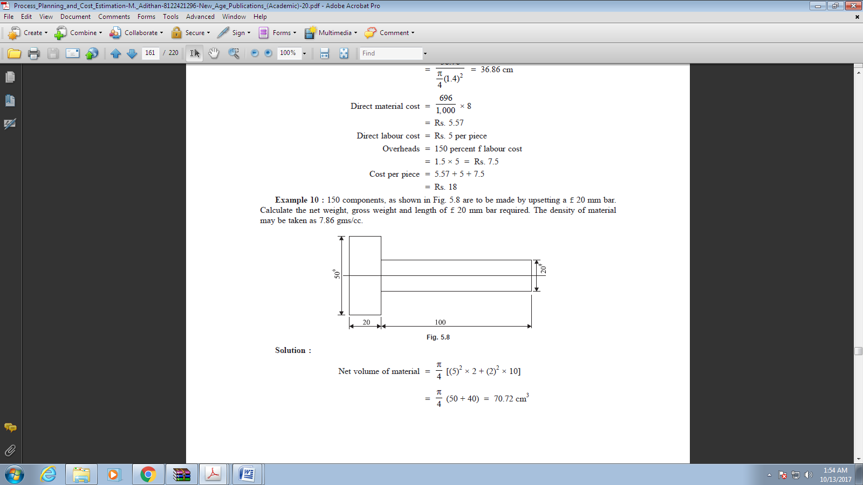

Figure.1

(ii) Explain various cost elements involved of a casting components. (8)

Or

(b) (i) Calculate the cost of forging a crank shaft as shown in Fig.2. The forging is to be made

out of a bar stock of 50 mm f and following data is available :

(i) Material price = Rs. 80 per kg

(ii) Direct labour charges = Rs. 23 per piece

(iii) Overhead charges = 150 percent of material cost

(iv) Density of material = 7.5 gms/cc

(v) Losses = 28 percent of net weight

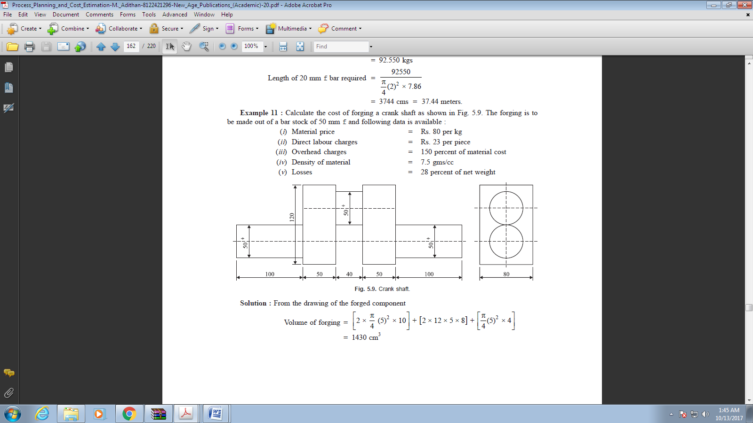

Figure 2 – crank shaft(All dimensions are in mm)

(ii) Explain various cost elements involved of a forged components. (8)