F Reg. No. :

Question Paper Code: 51078F

B.E./B.Tech. DEGREE EXAMINATION, NOV 2017
First Semester
Computer Science Engineering
15UME108 – ENGINEERING GRAPHICS
(Common to ECE,EIE,IT,Biomedical Engineering and Agriculture engineering)
(Regulation 2015)
Duration: Three hours Maximum: 100 Marks
Answer ALL Questions
PART - A (5 x 20 = 100 Marks)
1. | (a) | A line AB of 70 mm long has its end A at 10 mm above H.P and  15 mm in front of VP. Its front view and top view measure 50 mm and 60 mm respectively. Draw the projections of the line and determine its inclinations with HP and VP. | CO1- App | (20)
 |  | Or
 | (b) | Draw the projection of a square plate of 50 mm sides, having one  of its corners in HP and its surface is inclined at 65° to the HP and perpendicular to VP. | CO1- App | (20)
2. | (a) | Draw the projection of a square prism of size 30 mm and axis  60 mm with a solid diagonal vertical. | CO2- App | (20)
 |  | Or
 | (b) | A pentagonal prism with side of base 30mm and axis 60mm long is resting with an edge of its base on HP, such that the rectangular face containing that edge is inclined at 60° to HP. Draw the projections of the prism when its axis is parallel to V.P. | CO2- App | (20)
3. | (a) | A square prism of base 45 mm side and axis 70 mm height is resting on the ground on its base with its faces equally inclined to the VP. It is cut by a plane, perpendicular to the VP and inclined at 45° to the HP and meets the axis at a point 25 mm from the base. Draw the sectional plan. | CO3- App | (20)
 |  | Or
 | (b) | A cylinder of diameter of base 40 mm and height 50 mm is standing on its base on HP. A cutting plane inclined at 45° to the axis of the cylinder passes through the left extreme point of the top base. Develop the lateral surface of the truncated cylinder. | CO3- App | (20)
4. | (a) | A right circular cone of base diameter 60 mm and height 75 mm is cut by a plane making an angle of 30° with the horizontal. The plane passes through the midpoint of the axis. Draw the isometric view of the truncated solid. | CO4- App | (20)
 |  | Or
 | (b) | A cylinder of 50 mm diameter and 60 mm height stands on HP. A section plane Perpendicular to VP inclined at 55° to HP cuts the cylinder and passing through a point on the axis at a height of 45 mm above the base. Draw the Isometric view of the truncated portion of the cylinder such that the cut surface is clearly visible to the observer. | CO4- App | (20)
5. | (a) | Make free-hand sketches of front, top and right side views of the following pictorial view.  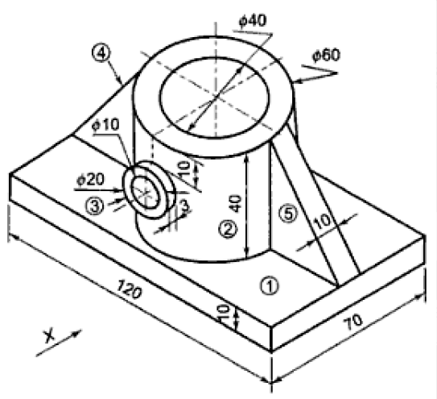 | CO5- App | (20)
 |  | Or
 | (b) | Draw the front, top and right side views of the following pictorial view.  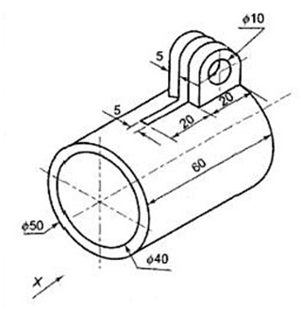 | CO5- App | (20)

