Reg. No. :

Question Paper Code: 41077

B.E./B.Tech. DEGREE EXAMINATION, NOV 2017
First Semester
Civil Engineering
14UME107 – ENGINEERING GRAPHICS
(Common to ALL branches)
(Regulation 2014)
Duration: Three hours Maximum: 100 Marks
Answer ALL Questions
PART - A (5 x 20 = 100 Marks)
1. | (a) | One end P of a line PQ, 60 mm long is 40 mm infront of the VP and 25 mm above the HP. The line is inclined at an angle of 40 to the HP and at an angle of 35 to VP. Draw the projections of PQ. | CO1- App | (20)
 |  | Or
 | (b) | The midpoint of a straight line AB 90 mm long is 60 mm above HP and 50 mm in front of VP. It is inclined 45° to VP and 30° to HP. Draw the projections of the line. | CO1- App | (20)
2. | (a) | A hexagonal prism of side of base 25 mm and axis 50 mm long is freely suspended from a corner of one end. Draw its projections by change of position method. | CO2- App | (20)
 |  | Or
 | (b) | Draw the projection of a pentagonal prism of 30 mm side of base and 65 mm long. It is lying on one of its longer edges on HP with one rectangular face perpendicular to HP such that the axis makes 60⁰ with VP. | CO2- App | (20)
3. | (a) | A hexagonal prism of base side 30 mm and axis length 60 mm rests on one of its ends on the HP with two base sides parallel to VP. It is cut by a plane perpendicular to the VP and inclined at angle of 40 to the HP. The cutting plane meets the axis at 30mm from the top. Draw the front view, sectional top view and the true shape of the section. | CO3- App | (20)
 |  | Or
 | (b) | A cone of base diameter 50 mm and axis length 65 mm stands with its base on HP. Draw the true shape of section made by a plane perpendicular to VP and inclined to the HP at 50° and passing through a point on the basic circle of the cone. | CO3- App | (20)
4. | (a) | A cylinder of 60 mm diameter and 70 mm height stands on HP. A section plane perpendicular to VP and inclined at an angle of 45⁰ to HP bisects the axis. Draw the isometric projection of the truncated cylinder. | CO4- App | (20)
 |  | Or
 | (b) | A square prism of base 20 mm side and height 50 mm rests on one of its ends on the HP. All the base sides of the prism are equally inclined to the VP. It is cut by a plane perpendicular to the VP and inclined at an angle of 45 to the HP that passes through a point on the axis 10 mm from the top. Draw the isometric projection of the solid. | CO4- App | (20)
5. | (a) | Draw the front, right side and top view of the given isometric drawing shown in figure below. All dimensions are in mm.  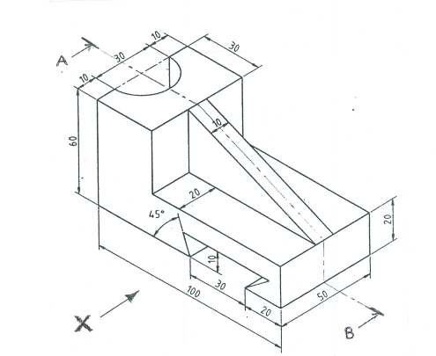 | CO5- App | (20)
 |  | Or
 | (b) | Draw the Front view, Top view and side view of the given object as shown in figure 1.  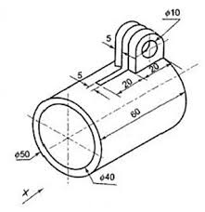 | CO5- App | (20)

