Reg. No. :

Question Paper Code: 31077

B.E./B.Tech. DEGREE EXAMINATION, NOV 2017
First Semester
Civil Engineering
01UME107 – ENGINEERING GRAPHICS
(Common to ALL branches)
(Regulation 2013)
Duration: Three hours Maximum: 100 Marks
Answer ALL Questions
PART - A (5 x 20 = 100 Marks)
1. | (a) | Sketch by free hand, the following views of the object shown in Figure 1. The dimensioning is also to be made by free hand. i) The front view in the direction of the arrow ii) the top view iii) the right side view  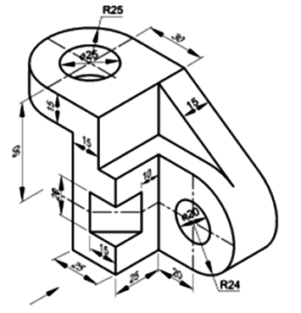 | CO1- App | (20)
 |  | Or
 | (b) | Draw the plan, elevation and left side view of the following object.  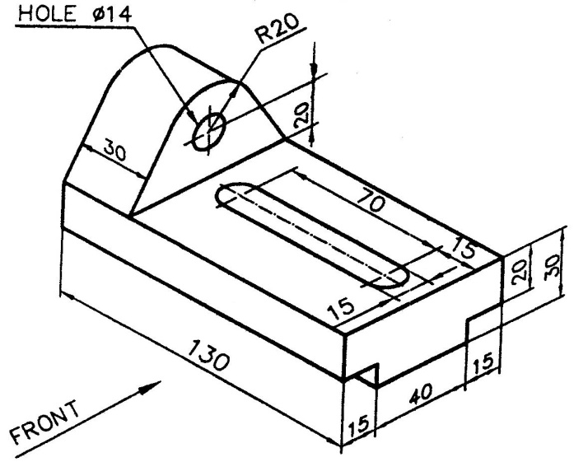 | CO1- App | (20)
2. | (a) | A 60⁰ set square has its shortest edge length 40 mm kept perpendicular to the VP so that the projection of the set-square on the HP is an isosceles triangle. Draw the projections and find the inclination of the set-square with the HP. | CO2- App | (20)
 |  | Or
 | (b) | A line AB measuring 85 mm has its end ‘A’ is 25 mm above the HP and 20 mm in front of the VP. The front view and top view measure 70 mm and 55 mm respectively. Draw the projections of the line and determine its true inclinations. | CO2- App | (20)
3. | (a) | A pentagonal prism side of base 25mm and axis 50mm long rests with one of its shorter edges on HP such that the base containing the edge makes an angle of 30º to HP and its axis is parallel to VP. Draw its projections. | CO3- App | (20)
 |  | Or
 | (b) | A cone of base diameter 60 mm and altitude 80 mm rests on the H.P. with its axis inclined at 30° to the H.P. and parallel to the V.P. Draw its front and top views by change of position method. | CO3- App | (20)
4. | (a) | A hexagonal pyramid of base side 25 mm and height 50 mm rests on the HP on one of its ends with two base edges parallel to the VP. It is cut by a plane perpendicular to the VP and inclined at 45° to the HP at a distance of 20 mm from the vertex on the axis. Draw the front view, sectional top view and true shape of the section. | CO4- App | (20)
 |  | Or
 | (b) | A pentagonal pyramid of base side 26 mm and altitude 52 mm is resting on H.P on its base with one of its base sides is perpendicular to V.P. It is cut by a plane inclined at 45⁰ to H.P and perpendicular to V.P and is bisecting the axis. Draw the front view, sectional top view and true shape of the section. | CO4- App | (20)
5. | (a) | A hexagonal prism of base side 25 mm and height 50 mm rests on the HP and one of the edges of its base is parallel to VP. A section plane perpendicular to VP and inclined at 50⁰ to HP bisects the axis of the prism. Draw the isometric projection of the truncated prism, showing the cut surface. | CO5- App | (20)
 |  | Or
 | (b) | A pentagonal pyramid, 30 mm edge of base and 65 mm height stands on H.P. such that an edge of the base is parallel to V.P. and nearer to it. A section plane perpendicular to V.P. and inclined at 30⁰ to H.P. cuts the pyramid passing through a point on the axis at a height of 35 mm from the base. Draw the isometric view of the truncated pyramid, showing the cut surface. | CO5- App | (20)

