|  |  |  |  |  |  |  |  |  |  |
| --- | --- | --- | --- | --- | --- | --- | --- | --- | --- |
|  |  |  |  |  |  |  |  |  |  |

**Reg. No. :**

**Question Paper Code: 52039**

B.E. / B.Tech. DEGREE EXAMINATION, NOV 2017

Second Semester

Electrical and Electronics Engineering

15UEE209 - ELECTRIC CIRCUITS

(Regulation 2015)

Duration: Three hours Maximum: 100 Marks

Answer ALL Questions

PART A - (10 x 1 = 10 Marks)

1. A branch of a network is said to be active when it consists of one

(a) resistor (b) Voltage source (c) inductor (d) capacitor

2. If one of the resistors in a parallel circuit is removed, what happens to the total resistance?

(a) Decrease (b) Increase (c) Remain constant (d) Exactly doubles

3. Thevenin’s equivalent is _______ source model.

(a) Current source (b) Voltage source (c) Both (d) None of these

4. The “Superposition theorem” is applicable for solving

(a)Linear network only (b) Non-linear network only (c)Linear and uni-lateral network (d)linear and bi-lateral network

5. What is the phase angle of a series RLC circuit at resonance?

(a) Zero (b) 90o (c) 45o (d) 30o

6. The coupling of the circuit is better when the value of K is

(a) 0 (b) 0.5 (c) 1 (d) 0.75

7. The condition for under damping is

(a) (R/2L)2 >1/LC (b) (R/2L)2 <1/LC (c) (R/2L)2 =1/LC (d) None of these

8. The power factor of a pure inductive circuit is

(a) Zero (b) One (c) 90o (c) 0.5

9. Three wattmeter method of power measurement can be used to measure power in

(a) Balanced circuit (b) Unbalanced circuits (c) Both unbalanced and unbalanced circuits (d) None of these

10. The line voltage is _______ times the phase voltage in star connection.

(a) 3 (b) √3 (c) 1/3 (d) 1/√3

PART - B (5 x 2 = 10 Marks)

11. State Kirchoff’s voltage law.

12. Give the condition for maximum power transfer in DC and AC circuits.

13. Define coefficient of coupling.

14. What is transient state?

15. Give the conditions for balanced star connected load.

PART - C (5 x 16 = 80 Marks)

16. (a) Determine the nodal voltages in the circuit. (16)

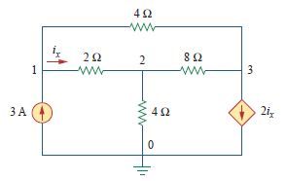

Or

(b) Calculate the node voltage and currents in all branches of the network Shown in the circuit. (16)

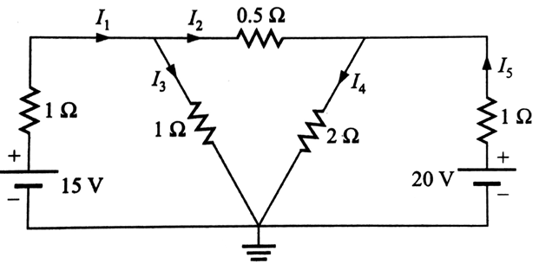

17. (a) State Thevenin’s theorem and Obtain the current through 10 ohm resistance using Thevenin’s theorem for the circuit shown below. (16)

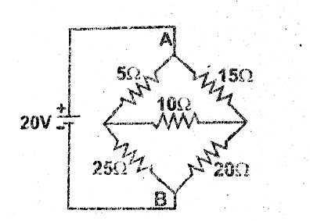

Or

(b) Explain maximum power transfer theorem and derive the expression for maximum power transfer. (16)

18. (a) A series RLC circuit consists of R=4ohm; L=0.5 H and a variable capacitance in series across a 100v, 50 Hz supply. Calculate the capacitance to give resonance and the voltage across the capacitance. (16)

Or

(b) (i) Two impedances *Z1=20+j10* and *Z2=10-j30* are connected in parallel and this combination is connected in series with *Z3=30+jX*.Find the value of *X* which will produce resonance. (8)

(ii) A series RLC circuit consists of a 50 *Ohm* resistance, 0.2*H* inductance and 10*µf* capacitor with an applied voltage of 20*V*.Determine the resonant frequency.

Find the *Q* factor of the circuit. Compute the lower and upper frequency limits and also find the bandwidth of the circuit. (8)

19. (a) In the circuit of the figure given below, find the expression for the transient current and the initial rate of growth of the transient current. (16)

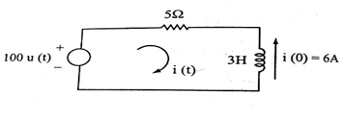

Or

(b) Derive and plot the step response of a series RLC circuit. (16)

20. (a) Three inductive coils each having resistance of 20 Ω and inductance of 0.05 H are

connected in star across a 400V, three-phase 50 Hz supply. Calculate: (i) Line

current (ii) Line voltage (iii) Phase current (iv) Phase voltage (v) Power factor (vi)

Power absorbed. (16)

Or

(b) Draw the circuit of 3 phase balanced star connected load with wattmeter for power measurement and also prove that two watt meters are sufficient to measure 3 phase power. (16)