|  |  |  |  |  |  |  |  |  |  |
| --- | --- | --- | --- | --- | --- | --- | --- | --- | --- |
|  |  |  |  |  |  |  |  |  |  |

**Reg. No. :**

**Question Paper Code: 42037**

B.E. / B.Tech. DEGREE EXAMINATION, NOV 2017

Second Semester

Electrical and Electronics Engineering

14UEE207- ELECTRIC CIRCUITS

(Regulation 2014)

Duration: Three hours Maximum: 100 Marks

Answer ALL Questions.

PART A - (10 x 1 = 10 Marks)

1. Six light bulbs are connected in parallel across 110 *V*. Each bulb is rated at 75 *W*. How much current flows through each bulb?

(a) 0.321 *A* (b) 0.682 *A* (c) 7.5 *A*  (d) 110 *A*

2. A 100 *Ω* resistor is connected across the terminals of a 9 *V* battery. What is the power

dissipation in the resistor?

(a) 9 *W* (b) 0.9 *W* (c) 0.19 *W* (d) 0.81 *W*

3. Three equal resistances of 9 *Ω* are connected in delta. What is the resistance in one of the arms in an equivalent star circuit?

(a) 3 *Ω* (b) 9 *Ω* (c) 1 *Ω*  (d) 27 *Ω*

4. Maximum power is transferred to load, when the load resistance is

(a) equal to half of the source resistance (b) equal to source resistance (c) equal to zero (d) equal to twice the source resistance

5. The maximum possible mutual inductance of two inductively coupled coils with self inductances *L1 =* 25 *mH* and *L2 =* 100 *mH* is given by

(a) 125 *mH* (b) 75 *mH* (c) 50 *mH* (d) 100 *mH*

6. The admittance and impedance of the following kind of network have the same properties

(a) LC (b) RL (c) RC (d) RLC

7. A terminal where three or more branches meet is known as

(a) node (b) terminus (c) combination (d) anode

8. An RL circuit has *R* = 2 *Ω* and *L* = 4 *H.* The time constant is

(a) 4*s* (b) 0.5*s* (c) 8*s* (d) 2*s*

9. A network which contains one or more than one source of e.m.f. is known as

(a) linear network (b) non-linear network

(c) passive network (d) active network

10. In a *Y-Y* system, a line voltage of 220 *V* produces a phase voltage of

(a) 381 *V* (b) 156 *V* (c) 127 *V* (d) 22 *V*

PART - B (5 x 2 = 10 Marks)

11. State reciprocity theorem.

12. State the Thevenin’s theorem.

13. Determine the quality factor for the series circuit consisting of *R* = 10 *Ω*, *L* = 0.1 *H*

and *C* = 10 *µF*.

14. Distinguish between the steady state and transient state response of an electrical circuit.

15. Compare the 3 phase star with delta connected system.

PART - C (5 x 16 = 80 Marks)

16. (a) In the given circuit below calculate (i) the equivalent resistance across the terminals of the supply (ii) total current delivered by the source (iii) power delivered to 16 *Ω*

resistor. (16)

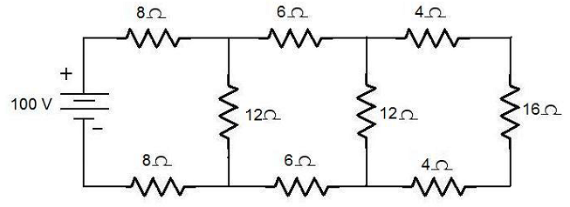

Or

(b) Calculate *Vo* from the following circuit shown below using mesh analysis. (16)



17. (a) Calculate the current in 10 *Ω* resistor of the network shown below using superposition theorem. (16)



Or

(b) Determine the load resistance to receive maximum power from the source; also find the maximum power delivered to the load in the circuit shown in below figure. (16)

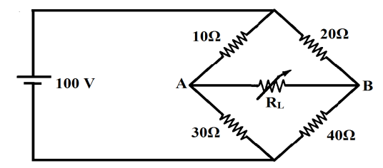

18. (a) State the condition for resonance in series RLC circuit and obtain the expression for resonant frequency. Derive the expression for bandwidth for a series RLC circuit as a function of resonant frequency. (16)

Or

(b) For a two-branch parallel circuit *RL* = 15 *Ω*, *RC* = 30 *Ω*, *XC* = 30 *Ω*, *E* = 120 *V* and *f* = 60 *Hz*. For the condition of resonance, calculate (1) the two values of *L* and (2) the two values of total current. (16)

19. (a) Derive the expression for the current *i(t)* in the series RC circuit: (a) with initial conditions (b) with relaxed initial conditions for a step input excitation, using Laplace transform technique. (16)

Or

(b) Find the *Y* parameters for the *RC* ladder network shown in Fig.8. (16)

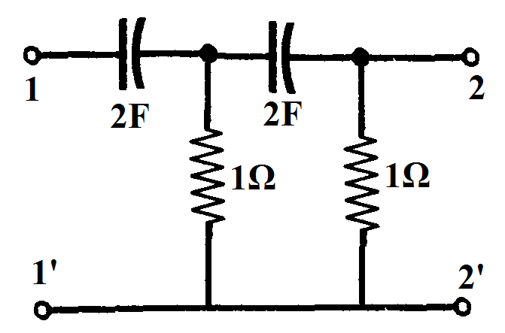

Fig.8

20. (a) Calculate the total power input and readings of the two wattmeters connected to measure power in a three phase balanced load, if the reactive power input is15 *KVAR*, and the load power factor is 0.8. Also compute load *KVA*. (16)

Or

(b) With a neat circuit and phasor diagram explain the three phase power and power factor measurement by two Wattmeter method. (16)