|  |  |  |  |  |  |  |  |  |  |
| --- | --- | --- | --- | --- | --- | --- | --- | --- | --- |
|  |  |  |  |  |  |  |  |  |  |

**Reg. No. :**

**Question Paper Code: 32037**

B.E. / B.Tech. DEGREE EXAMINATION, NOV 2017

Second Semester

Electrical and Electronics Engineering

01UEE207- ELECTRIC CIRCUITS

(Regulation 2013)

Duration: Three hours Maximum: 100 Marks

Answer ALL Questions.

PART A - (10 x 2 = 20 Marks)

1. A fluorescent tube choke is connected across 230V, 50Hz AC supply. If the resistance and reactance of the choke are 100Ω, 1H respectively, determine the current through the choke.

2. What are the limitations of Ohm’s law.

3. Write some applications of maximum power transfer theorem.

4. State Norton’s theorem?

5. What is co-efficient of coupling?

6. Sketch the frequency response of a single tuned circuit.

7. Write the purpose of Laplace transformation in the circuit analysis.

8. A RL series circuit with R=10 Ω is excited by a dc voltage source of 30 V by closing the switch at t = 0. Determine the current in the circuit at t = 2τ.

9. List out the methods of power measurement in three phase balanced circuits.

10. What are the advantages of 3-phase system over 1-phase system?

PART - B (5 x 16 = 80 Marks)

11. (a) Calculate the currents supplied by the two batteries in the network shown below.

(16)

3Ω

5Ω

8 A

2Ω

4Ω

2Ω

20 V

4 A

Or

(b) Using nodal analysis, calculate the current through the 5 Ω resistor in the circuit shown in figure 2. (16)

Figure 2

3Ω

5Ω

8 A

2Ω

4Ω

2Ω

20 V

4 A

12. (a) Find Rin for the network shown in figure, by using *Υ* - *Δ* and *Δ - Υ*

transformations. (16)

**1**

*Ω*

6

*Ω*

**0.6**

*Ω*

6

*Ω*

3

*Ω*

2

*Ω*

1

*Ω*

5

*Ω*

4

*Ω*

R

in

Or

(b) (i) Use source transformation to find I0 in the circuit shown in figure. (8)

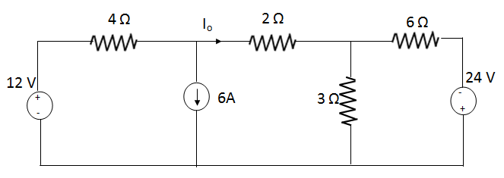

(ii) For the circuit shown in Fig., determine the load current using Thevenin’s theorem? (8)

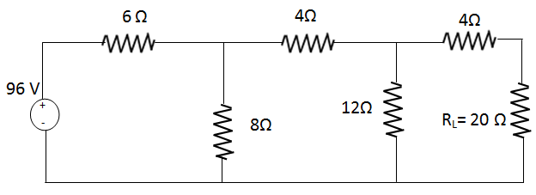

13. (a) A series RLC circuit consists of *R* = 16 Ω, *L* = 5 *mH* and C = 2 *µF*. Calculate the quality factor, bandwidth and half power frequencies. (16) Or

(b) Discuss about Single tuned and Double tuned circuits. (16)

14. (a) A RL series circuit is excited by a sinusoidal source *e(t) = 10 sin 100t* volts, by closing the switch at *t* = 0. Take *R* = 10 Ω and *L* = 0.1 *H*. Determine the current *i(t)* flowing through the *RL* circuit. (16)

Or

(b) Derive the expression for transient response in series R-L-C circuit for DC excitation. Obtain the solution using Laplace transforms. (16)

15. (a) A symmetrical three-phase, three wire 440 V, supply is connected to a star- connected load. The Impedances in each branch are ZR = 2 + j3 Ω, ZY = 1- j2 Ω and ZB = 3 + j4 Ω. Find its equivalent delta connected load. (16)

Or

(b) (i) Derive the formula for total power consumed in unbalanced *Y* connected load. (8)

(ii) Explain a method to determine power factor in 3-phase system. (8)