|  |  |  |  |  |  |  |  |  |  |
| --- | --- | --- | --- | --- | --- | --- | --- | --- | --- |
|  |  |  |  |  |  |  |  |  |  |

**Reg. No. :**

**Question Paper Code: 43054**

B.E. / B.Tech. DEGREE EXAMINATION, NOV 2017

Third Semester

Electronics and Instrumentation Engineering

14UEI304 - ELECTRICAL CIRCUITS AND NETWORKS

(Common to Instrumentation and Control Engineering)

(Regulation 2014)

Duration: Three hours Maximum: 100 Marks

Answer ALL Questions

PART A - (10 x 1 = 10 Marks)

1. A 100Ω resistor is connected across the terminal of 2.5V battery. What is the power dissipation in the resistor?

(a) 25W (b) 100W (c) 0.4W (d) 6.25W

2. If there are n resistors each of R *ohms* connected in parallel, the equivalent resistance is

(a) n/ R (b) R/n (c) n R (d) 1/ nR

3. Thevenin resistance Rth is found

(a) By removing voltage source along with their internal resistance (b) By short-circuiting the given two terminals

(c) Between any two open terminals

(d) Between same open terminals

4. Three equal resistance of 3 Ω are connected in star. What is the resistance in one of the arms in an equivalent delta circuit?

(a) 10 Ω (b) 3 Ω (c) 9 Ω (d) 27 Ω

5. In a series circuit of L = 15mH, C = 0.015µF and R = 80 Ω, What is the impedance at the resonant frequency?

(a) (15mH)ὠ (b) 80 Ω (c) (0.015F) ὠ (d) 1/ (ὠ x 0.015)

6. The maximum value of the coefficient of coupling is

(a) 100*%* (b) more than 100*%* (c) 90*%* (d) between 90*%* and 100*%*

7. The time constant of a series RC circuit is

(a) R/C (b) e-RC (c) 1/RC (d) RC

8. The time constant of a series RC circuit is

(a)  (b)  (c)  (d) 

9. The relation between the line and phase current in a three phase star connected system

(a) *IL = Iph* (b) *IL = 3Iph* (c) *IL = Iph* (d) *IL = Iph/*

10. In a three-phase system, the voltages are separated by

(a) 80o (b) 120o (c) 45o (d) 90o

PART - B (5 x 2 = 10 Marks)

11. Write Kirchoff's laws mathematically.

12. Determine the current through each resistor in the circuit shown in below figure.

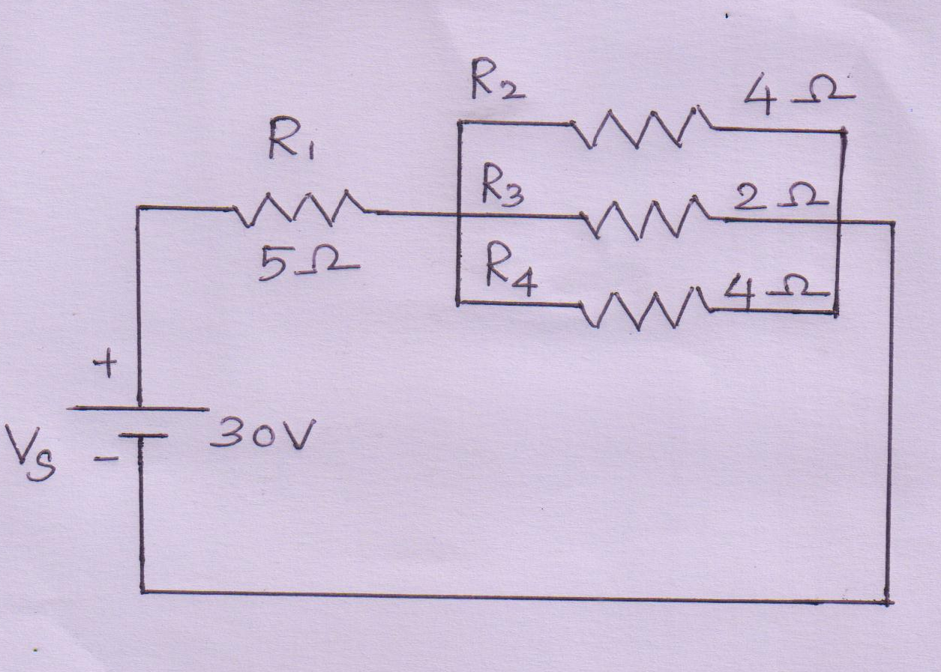

13. Define co-efficient of coupling.

14. Define a time constant of RC circuit.

15. List any two advantages of three phase system over single phase system.

PART - C (5 x 16 = 80 Marks)

16. (a) For the circuit shown in below, find the voltage across the 4 *ohm* resistor by using nodal analysis. (16)

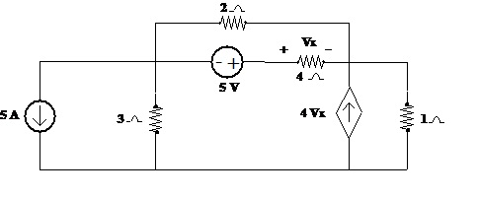

Or

(b) Apply Kirchhoff”s current law and voltage law to the circuit given below. Indicate the various branch currents. Write down the equations relating the various branch currents. Solve these equations to find the values of these currents. (16)

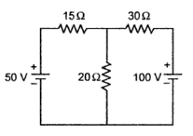

17. (a) Determine Thevenin’s equivalent across the terminals AB for the circuit shown in figure below. (16)

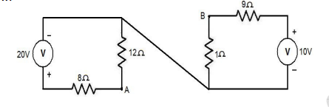

Or

(b) A loud speaker is connected across the terminals *A* and *B* of the network shown in fig. What should be the value of impedance of the speaker to obtain maximum power

transferred to it and what is the maximum power? (16) 

18. (a) Derive bandwidth for a series RLC circuit as a function of resonant frequency. (16)

Or

(b) (i) Derive the formula for mutual inductance in terms of coefficient of coupling and self inductance. (12)

(ii) With a neat sketch, explain briefly about the single tuned circuit. (4)

19. (a) A Series RLC circuits has R=50 ohm, L= 0.2H, and C = 50 microfarad. Constant voltage of 100V is impressed upon the circuit at t=0. Find the expression for the transient current assuming initially relaxed conditions. (16)

Or

(b) Derive an expression for current response of a series RLC circuit when excited by a constant voltage source. (16)

20. (a) Prove that the power measured in three phase circuit by the two watt meter method is $\sqrt{3 }$ VLILCos θ. (16)

Or

(b) With a neat circuit and phasor diagram, explain the three phase power measurement by two wattmeter methods. (16)