|  |  |  |  |  |  |  |  |  |  |
| --- | --- | --- | --- | --- | --- | --- | --- | --- | --- |
|  |  |  |  |  |  |  |  |  |  |

**Reg. No. :**

**Question Paper Code: 44050**

B.E. / B.Tech. DEGREE EXAMINATION, NOV 2017

Fourth Semester

Electronics and Communication Engineering

14UEI422 – LINEAR CONTROL ENGINEERING

(Regulation 2014)

Duration: Three hours Maximum: 100 Marks

Answer ALL Questions

PART A - (10 x 1 = 10 Marks)

1. __________ is a closed loop system

(a) Auto pilot for an aircraft system (b) Direct current generator

(c) Car Starter (d) Electric switch

2. The transfer function of the given block diagram is

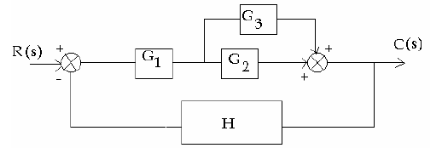

(a)  (b) 

(c)  (d) 

3. Velocity error constant of the system is measured when the input to the

system is function

(a) Parabolic (b) Ramp (c) Impulse (d) Step

4. The steady-state error of a feedback control system with an acceleration input becomes finite in a

(a) Type 0 system (b) Type 1 system (c) Type 2 system (d) Type 3 system

5. Which of the following is the time domain method of determining stability of a control system

(a) Bode plot (b) Nyquist plot (c) Root locus (d) Nichols chart

6. The frequency at which the phase of the open loop transfer function is

(a) 0° (b) 180° (c) 360° (d) 60°

7. The relative stability of a system is given by

(a) Gain margin alone (b) Phase margin alone (c) Both gain and phase margin (d) Either gain or phase margin

8. The equation  has _________ number of roots in the left half of s–plane.

(a)One (b)Two (c)Three (d)Four

9. The advantage of state space model is

(a) Applicable for linear and non-linear system (b) Applicable for only linear system controllable (c) Applicable for time invariant system only (d) Applicable for continuous –time system only

10. The state space approach is applicable to the control systems which are

(a) Time variant (b) Time invariant (c) Both (a) and (b) (d) None of these

PART - B (5 x 2 = 10 Marks)

11. Why negative feedback is invariably preferred in closed loop system?

12. Define steady state error.

13. Define Gain margin.

14. What is the relation between stability and co-efficient of characteristic polynomial?

15. State the reason for using state space analysis rather than using transfer function method.

PART - C (5 x 16 = 80 Marks)

16. (a) Write the differential equations governing the Mechanical system shown in figure and determine the transfer function. (16)



Or

(b) Determine the transfer function  for the block diagram shown in Figure by

first drawing its signal flow graph and then using the Mason’s gain formula. (16)

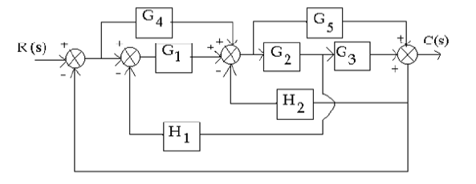

17. (a) Briefly explain the effects of adding poles and zeros to second order systems.(16)

Or

(b) Obtain the response of unity feedback system whose open loop transfer

function is

*G*(*s*) 4 when the input is unit step. (16)

*s*(*s+* 5)

18. (a) Sketch the bode plot for the following transfer function and find the system gain

K for the gain cross over frequency to be 5 rad/sec.

G(s)= . (16)

Or

(b) The open loop transfer function of a unity feedback system is. Sketch the Polar plot and determine the Gain margin and Phase margin. (16)

19. (a) Using Routh criterion determine the stability of the system whose characteristics equation is s6 +s5-2s4-3s3-7s2-4s-4 =0. Find the number of roots falling in the

RHS plane and LHS plane. (16)

Or

(b) Construct a Routh array and determine the stability of the system whose characteristic equation is .

*s* 6 + 2*s*5 + 8*s* 4 +12*s*3 +20*s* 2 +16*s +*16= 0.

Also determine the number of roots lying on right half of s-plane, left half of s-plane and on imaginary axis. (16)

20. (a) Find the state controllability for the systems represented by the state equation

. (16)

Or

(b) Explain sampling theorem and Sample and Hold operation in detail. (16)