|  |  |  |  |  |  |  |  |  |  |
| --- | --- | --- | --- | --- | --- | --- | --- | --- | --- |
|  |  |  |  |  |  |  |  |  |  |

**Reg. No. :**

**Question Paper Code:45001**

B.E. / B.Tech. DEGREE EXAMINATION, NOV 2017

FifthSemester

Computer Science and Engineering

14UMA521 -DISCRETE MATHEMATICS

(Regulation 2014)

(Common to IT Branch)

Duration: Threehours Maximum: 100 Marks

Answer ALL Questions

PART A - (10 x 1 = 10 Marks)

1. is equivalent to ­­­­­­­­­­­­­­

(a) (b) (c) (d)

2. Let with universe of discourse as all

positive integers. Then the truth value of $\left(∃x\right)\left(P(x)→Q(x)\right)$ is

(a) True (b) False (c) 10 (d) 20

3. Solve for n:

(a) 2 (b) 6 (c) 4 (d) 42

4. In how many different ways can the letters of the word 'LEADING' be arranged in such a

way that the vowels always come together?

1. 620 (b) 710 (c) 720 (d) 610

5. The number of vertices in a regular graph of degree 4 with 10 edges is

(a) 4 (b) 10 (c) 6 (d) 5

6. The number of vertices in a regular graph of degree 4 with 10 edges is

(a) 4 (b) 10 (c) 6 (d) 5

7. The set of all real number usual multiplication is not a group, since

(a) Multiplication is not a binary operation (b) Multiplication is not associative

(c) Identity element does not exist (d) Zero has no inverse

8. The necessary and sufficient condition for a non-empty subset $H$ of a group $G$ to be a

subgroup when $a,b∈H$ is

(a) $a^{-1}*h*a ∈H$ (b) $a^{-1}*b ∈H$ (c) $a^{-1}*b^{-1} ∈H$ (d) ${\left(a*b\right)}^{-1}∈H$

9.A self-complimented, distributive lattice is called

(a) Modular Lattice (b) Boolean Algebra (c)Complete Lattice (d) Self-Dual Lattice

10. A Lattice $\left(L,∧,∨\right)$ is said to be modular if for $a≤c,$ then

(a) $a∨b=b∨c$ (b) $a∨\left(b∨c\right)=a∧\left(b∧c\right)$

(c) $a∧\left(b∧c\right)=a∨\left(b∧c\right)$ (d) $a∨\left(b∧c\right)=\left(a∨b\right)∧c$

PART - B (5 x 2 = 10 Marks)

11. Using truth table, show that is tautology.

12. Show that if seven colours are used to paint 50 bicycles, atleast 8 bicycles will be the same colour.

13. **Give an example of a graph which is both Eulerian and Hamiltonian**?

14. **Draw all the spanning trees of** .

15. Is the poset $\left(Z^{+},/\right)$ a lattice?

PART - C (5 x 16 = 80 Marks)

16. (a) (i) **Without using the truth table, find the PCNF and PDNF of the statement $\left(⏋P⟶R \right)∧\left(Q⟷P\right)$.** (8)

(ii) Show that $\left(x\right)\left(P\left(x\right)\bigvee{Q\left(x\right)}\right)⇒ \left(x\right)P\left(x\right)\bigvee{\left( ∃x\right)Q\left(x\right)}$. (8)

Or

(b)(i) Use the indirect method to prove that the conclusion $\left(∃z\right)Q(z)$ follows from the premises $\left(∀x\right)\left(P(x)→Q(x)\right)\text{and }\left(∃y\right)P\left(y\right)$. (8)

(ii) Show

. (8)

17. (a) (i) Solve the recurrence relation $y_{n+2}-{6y}_{n+1}+9y_{n}=0, y_{1}=4 and y_{0}=1$. (8)

(ii) Use the method of generating function to solve the recurrence relation

${ a}_{n}=4a_{n-1}-4a_{n-2}+4^{n};n≥2,$ given that $a_{0}=2 \text{and }a_{1}=8$. (8)

Or

(b) (i) Find the number of integers between 1 to 250 that are not divisible by any of the

integers 2,3,5 and 7. (8)

(ii) From a committee consisting of 6 men and 7 women, in how many ways can we

select a committee of (8)

(1) 4 members which has atleast one woman

(2) 4 members that has at most one man

(3) 4 members of both sexes.

18. (a) (i) Examine whether the following graphs are isomorphic. (8) 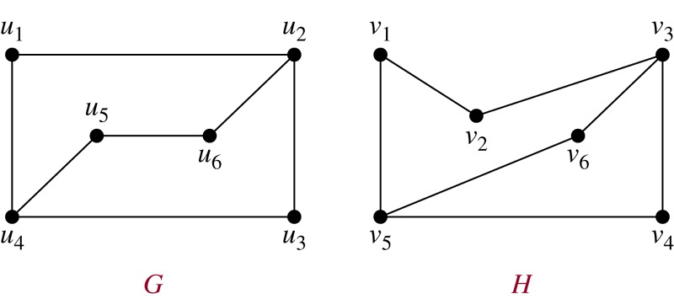Or

(ii) Prove that a connected graph is Eulerian if all vertices are of even degree. (8)

Or

(b) (i) Prove that a simple graph with *n* vertices must be connected if it has more than $\frac{\left(n-1\right)\left(n-2\right)}{2}$ edges. (8)

(ii) Find the adjacency matrix of the following graph *G*. Find

$A^{2}, A^{3}and Y=A+A^{2}+A^{3}+A^{4}$. What is your observation of entries in ? (8)

19. (a) (i) Let be defined on $R$ by $x*y=x+y+2xy ∀x,y∈R.$ Check whether $\left(R,*\right)$

is a monoid (or) not. Is it commutative? Also find the inverses of $\left(R,*\right).$

(8)

(ii) State and prove Lagrange’s theorem. (8)

Or

(b) (i) Prove that a non-empty subset H of a group G is a subgroup if

$a,bϵH⇒a*b^{-1}ϵH.$ (8)

(ii) Let $f:G→G$ be a homomorphism of group G with kernel *K*. Then prove that *K* is a normal subgroup of *G* and *G/K* is isomorphic to image of . (8)

20. (a) (i) State and prove DeMargon’s law of lattice. (8)

(ii) In a complemented, distributive lattice, prove the following: (i) ${\left(ab\right)}^{'}+{\left(a+b\right)}^{'}=a^{'}+b'$ (ii) $ab^{'}c+ab^{'}c=b'c$ (8)

Or

(b) (i) State and prove distributive inequality of Lattice. (8)

(ii) In any Boolean algebra, show that $a'b+ab'=0 iff a=b.$ (8)