|  |  |  |  |  |  |  |  |  |  |
| --- | --- | --- | --- | --- | --- | --- | --- | --- | --- |
|  |  |  |  |  |  |  |  |  |  |

**Reg. No. :**

**Question Paper Code: 51329**

B.E. / B.Tech. DEGREE EXAMINATION, NOV 2016

Second Semester

Electrical and Electronics Engineering

15UEE209 - ELECTRIC CIRCUITS

(Regulation 2015)

Duration: Three hours Maximum: 100 Marks

Answer ALL Questions

PART A - (10 x 1 = 10 Marks)

1. A branch of a network is said to be active when it consists of one

(a) resistor (b) Voltage source (c) inductor (d) capacitor

2. Mesh analysis is applicable to the circuit containing only ______ sources.

(a) current (b) Voltage (c) Both (d) None of these

3. When finding the resistance, voltage source is replaced by

(a) open circuit (b) short circuit (c) resistance (d) None of these

4. Thevenin’s equivalent is _______ source model.

(a) Current source (b) Voltage source (c) Both (d) None of these

5. At resonant condition, RLC circuit behaves purely _______ circuit.

(a) resistor (b) inductor (c) capacitor (d) None of these

6. The coupling of the circuit is better when the value of K is

(a) 0 (b) 0.5 (c) 1 (d) 0.75

7. Time constant of RL series circuit

(a) L/R (b) RC (c) RL (d) R/L

8. The condition for under damping is

(a) (R/2L)2 >1/LC (b) (R/2L)2 <1/LC (c) (R/2L)2 =1/LC (d) None of these

9. The line voltage is _______ times the phase voltage in star connection.

(a) 3 (b) √3 (c) 1/3 (d) 1/√3

10. Which method is used for measuring load power in 3phaae balanced load

(a) One Wattmeter (b) Two Wattmeter (c) Three Wattmeter (d) None of these

PART - B (5 x 2 = 10 Marks)

11. State Kirchoff’s voltage law.

12. State Thevenin’s theorem.

13. Define resonance frequency for a series RLC circuit.

14. What is transient state?

15. Define Power factor.

PART - C (5 x 16 = 80 Marks)

16. (a) (i) Find Req for the resistive network shown below between terminals A and B. (10)

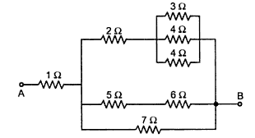

(ii) Calculate the total current I flowing through the given electrical network. (6)



Or

(b) Calculate the node voltage and currents in all branches of the network Shown in the circuit. (16)

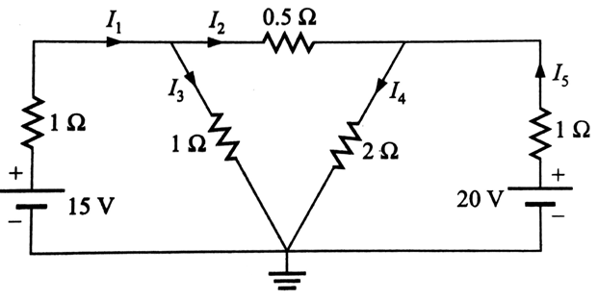

17. (a) Determine the load resistance to receive the maximum power from the source and also find the maximum power delivered to the load in the circuit. (16)

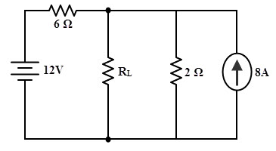

Or

(b) Use Thevenin’s theorem to find the current through 5Ω resistance. (16)

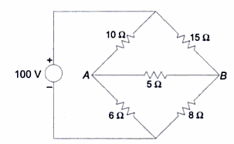

18. (a) (i) Two coupled coils with response self-inductance L1 = 0.8 H and L2 = 0.2 H have coupling coefficient of 0.6. Find the total inductance if the coils are connected in (i) Series aiding and opposing (ii) Parallel aiding and opposing. (8)

(ii) A series RC circuit with R = 8Ω and Xc = 4Ω is connected in parallel with series RL circuit with XL= 1Ω and resistance RL. Determine the value of RL for which the circuit is at resonant condition. (8)

Or

(b) (i) A coil of resistance 40Ω and inductance 0.75 H form the part of a series circuit for which the resonance frequency is 55Hz. If the supply is 250V, 50 Hz. Find the line current, power factor, voltage across the coils. (10)

(ii) A primary coil having an inductance of 100μH is connected in series with a secondary coil of 240μH inductance and the total equivalent inductance is 146μH. Determine the coefficient of coupling. (6)

19. (a) (i) A series RL circuit with R=60Ω and L=30H has a constant voltage V=120V applied at t=0.Determine the current, the voltage across the resistor and voltage across the inductor. (8)

(ii) A series RC circuit with R =10Ω and C= 0.1F has a constant voltage V=20V applied at t=0 as show in circuit. Obtain the current equation, voltage across resistor and the voltage across the capacitor. (8)

Or

(b) A series RLC circuit comprising R=10 Ω, L=0.5 H and C=1 µF is excited by constant voltage source of 100V. Obtain the expression for the current. Assume that the circuit is relaxed initially. (16)

20. (a) (i) The two wattmeter method is used to measure power in a three-phase load. The wattmeter readings are 400 W and -35 W. Calculate (i) total active power (ii) power factor and (iii) reactive power. (6)

(ii) A balanced delta-connected load of 50 Ω per phase is connected to a balanced three phase 230 V supply. Find the (i) Line current (ii) Line voltage (iii) Phase current (iv) Phase voltage and (v) Total power of the circuit. (10)

Or

(b) Three inductive coils each having resistance of 20 Ω and inductance of 0.05 H are connected in star across a 400V, three-phase 50 Hz supply. Calculate: (i) Line current (ii) Line voltage (iii) Phase current (iv) Phase voltage (v) Power factor (vi) Power absorbed. (16)